**The Viola-Jones algorithm**

The heart of OpenCv. Created by Paul Viola and Michael Jones in 2001.



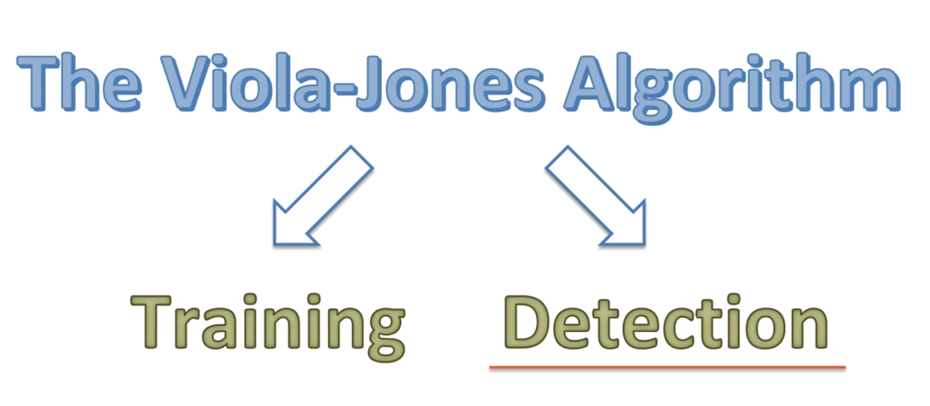

It’s designed to best work for frontal faces. So first a picture is turned into gray scale. Results are astonishing and there’s less data to process. Then it starts looking for the face – features of the face-using a box from the top left.

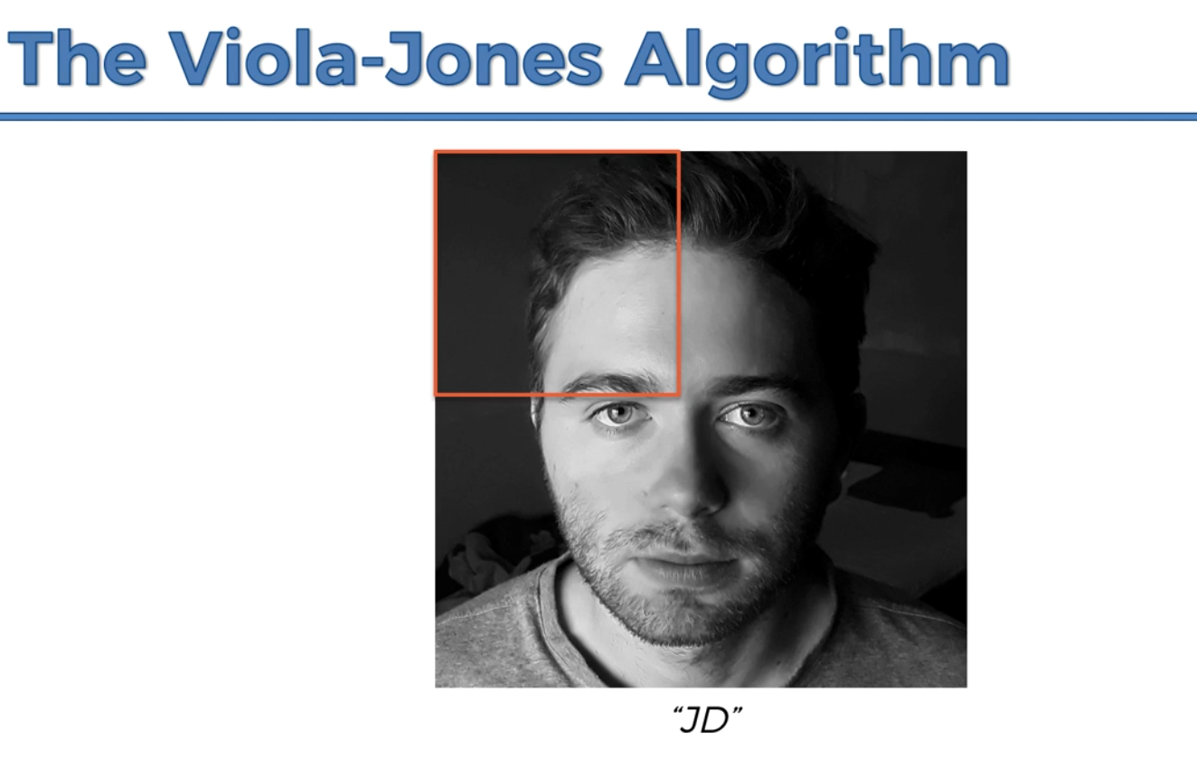

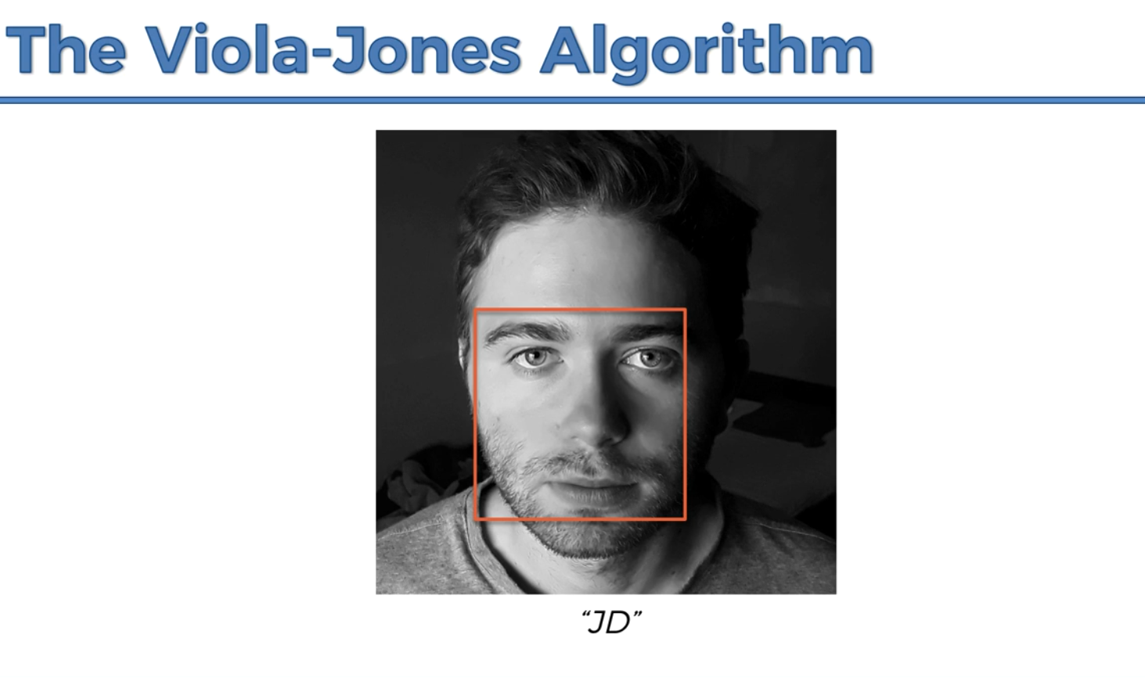

When reaches here it marks it as a high potential to be a face.

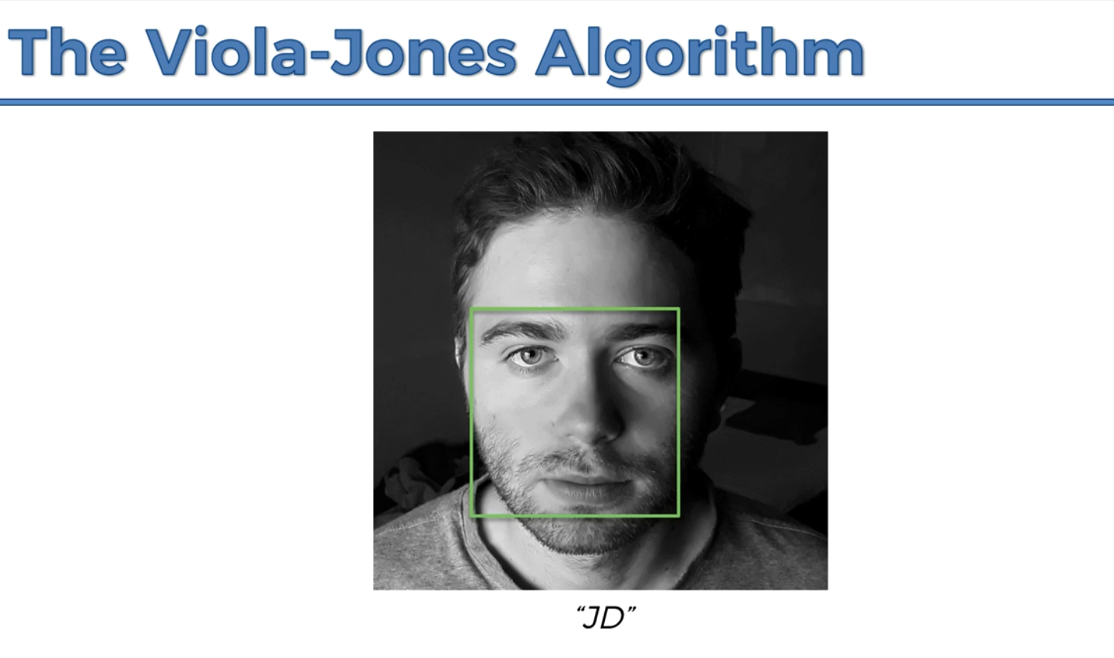

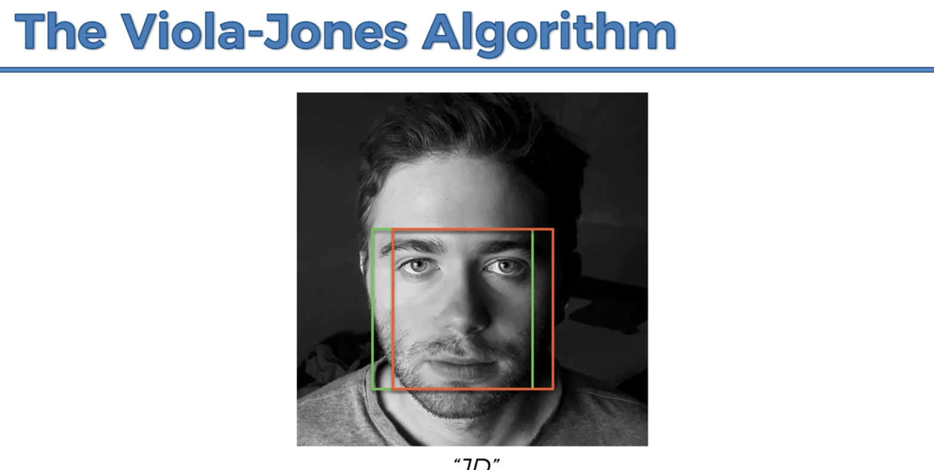

Then in this box it can see another face so it’s marked.

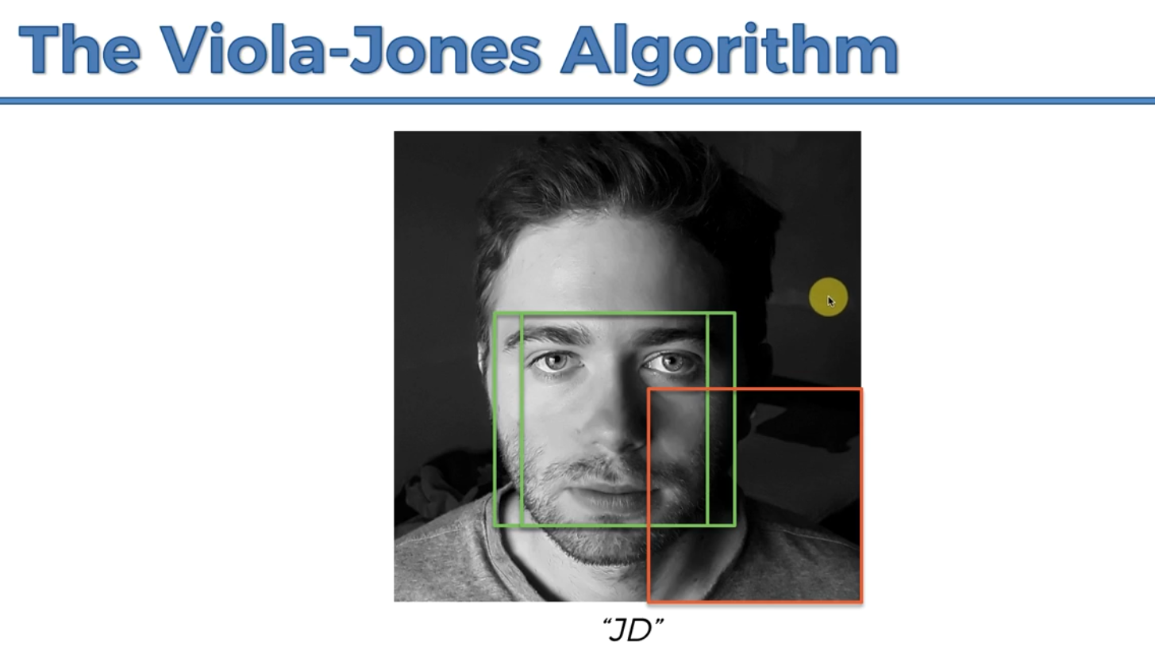

The boxes will vary in reality and the steps will be smaller.

**Haar-like Features**

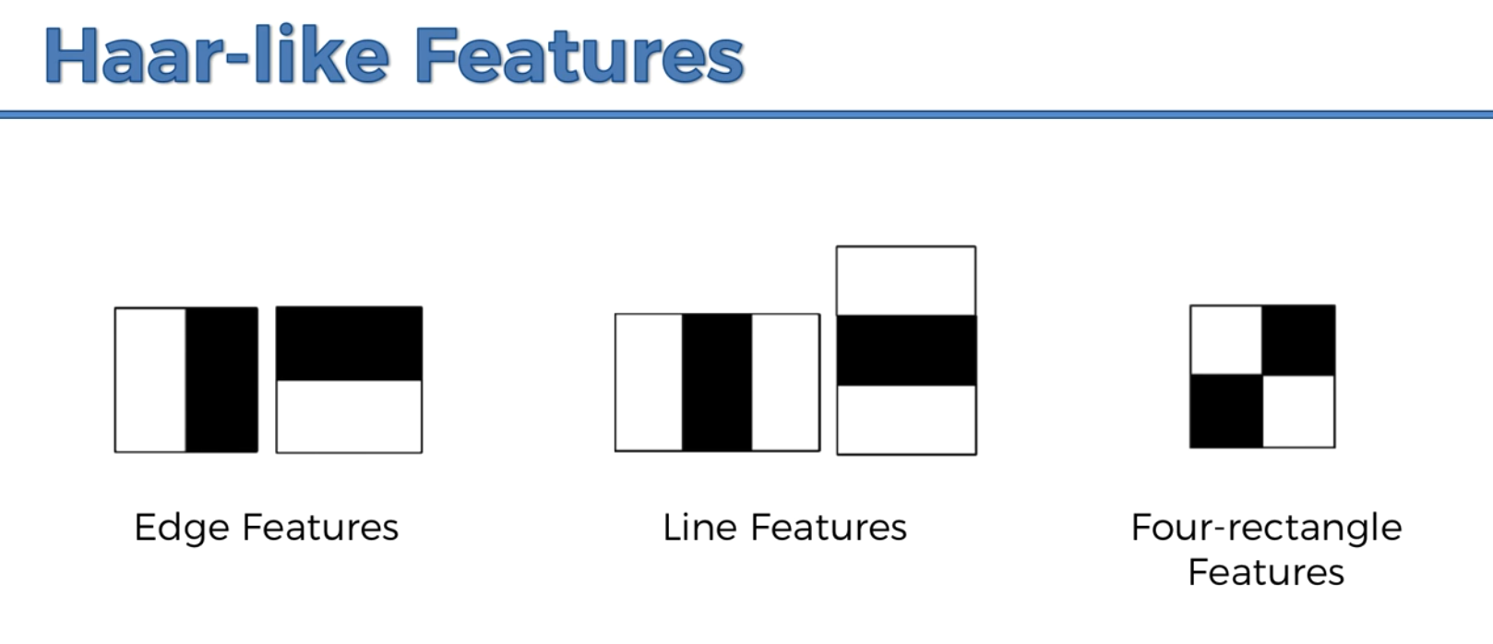

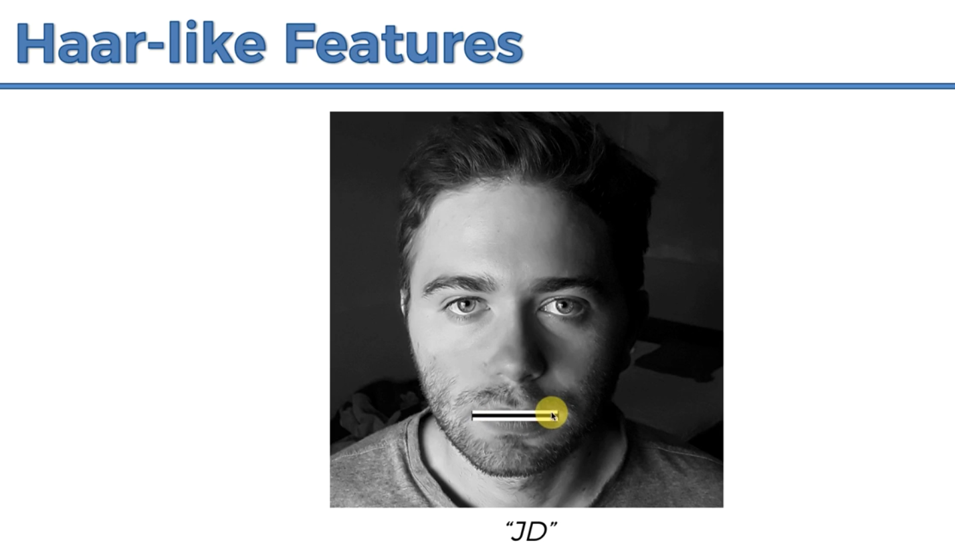

Above is an example of a line feature

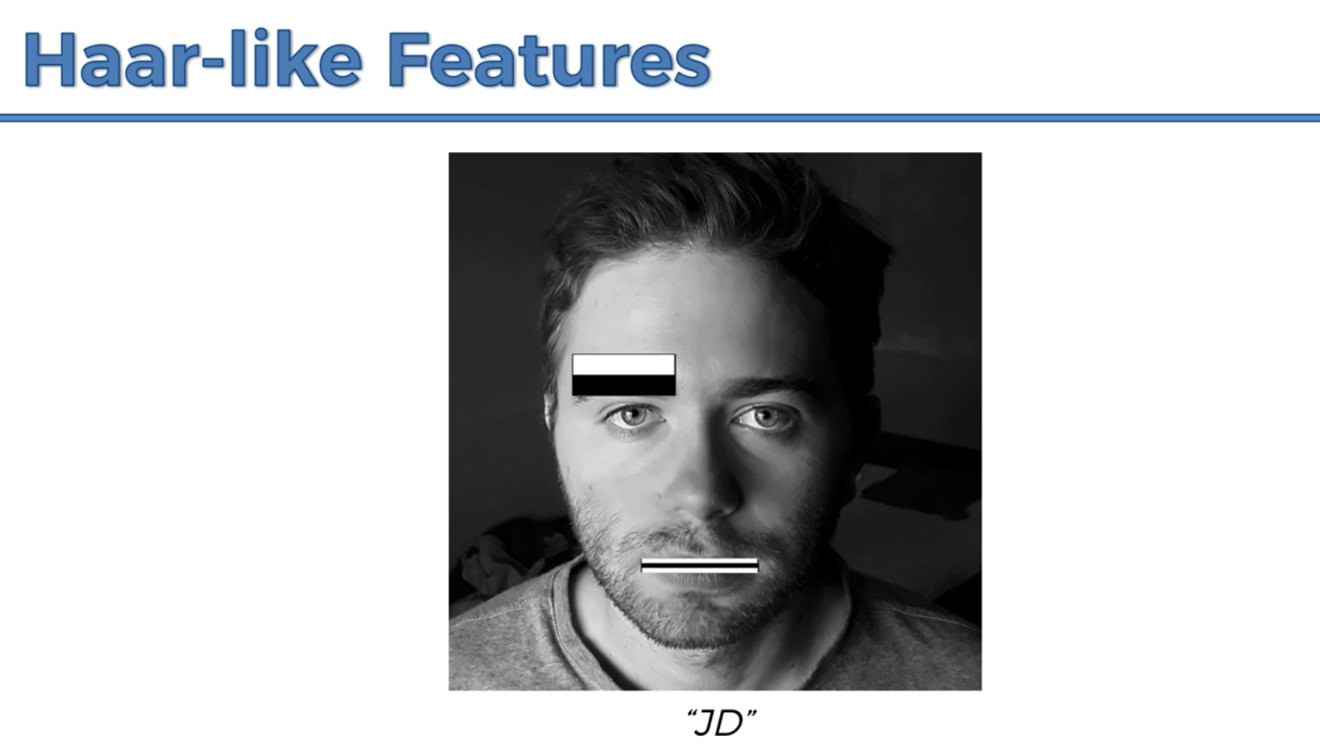

Above, is an edge feature.

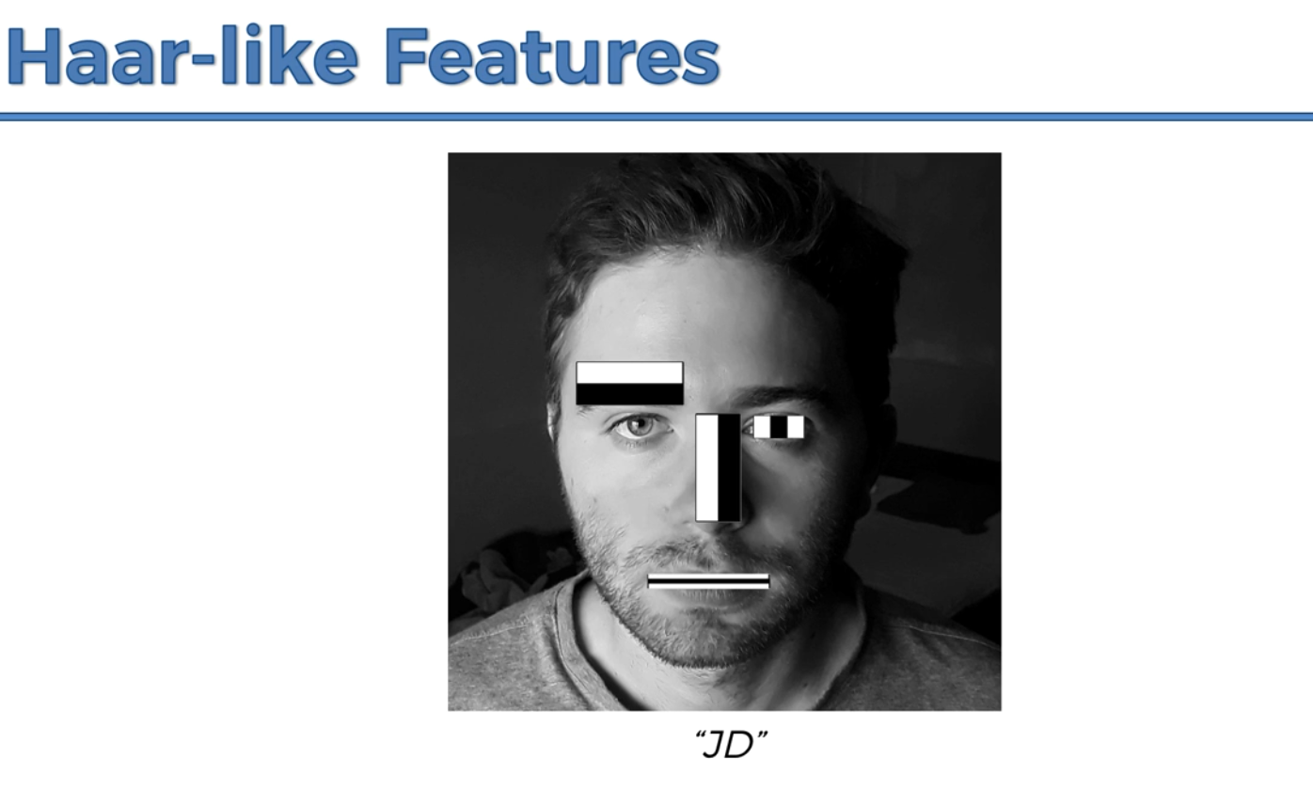

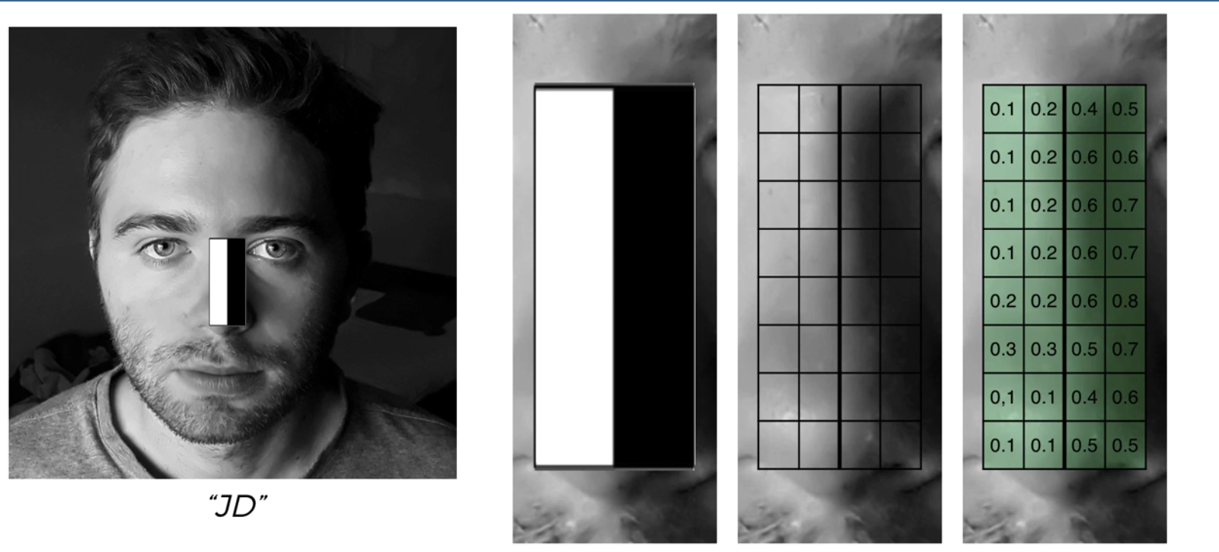

The pixels are from 0 to 255 but they’ve been normalized.

The viola jones algorithm will get the average intensity of both the black and white pixels. i.e. sums up the white pixels divided by the number of white pixels, similarly for the black pixels. Then it subtracts one intensity from the other.

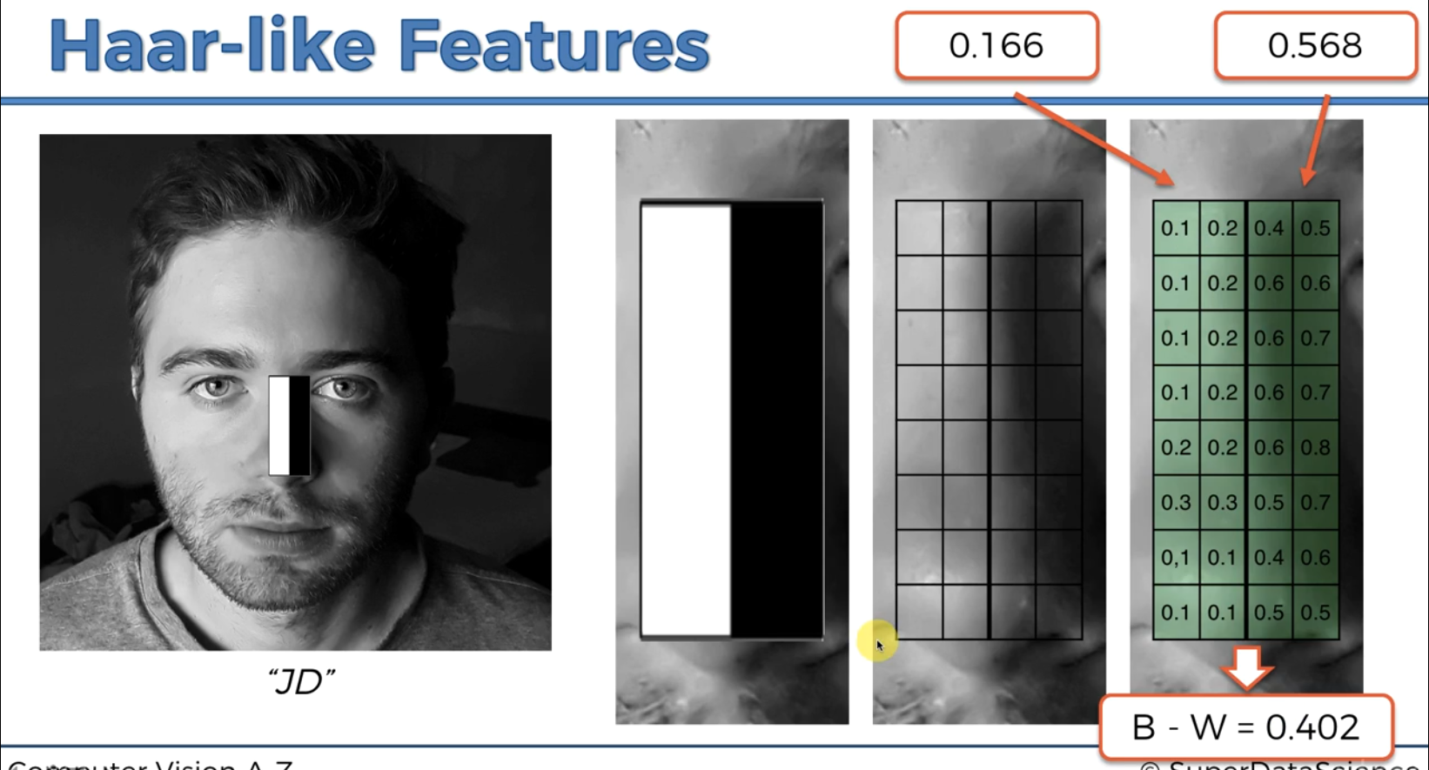

You’re supposed to set a threshold to identify a certain Haar-like feature e.g. here the threshold is 0.3 for the line Haar-like feature that identifies a nose hence this point in the image qualifies to have a Line Haar-like feature.

**Integral Image**

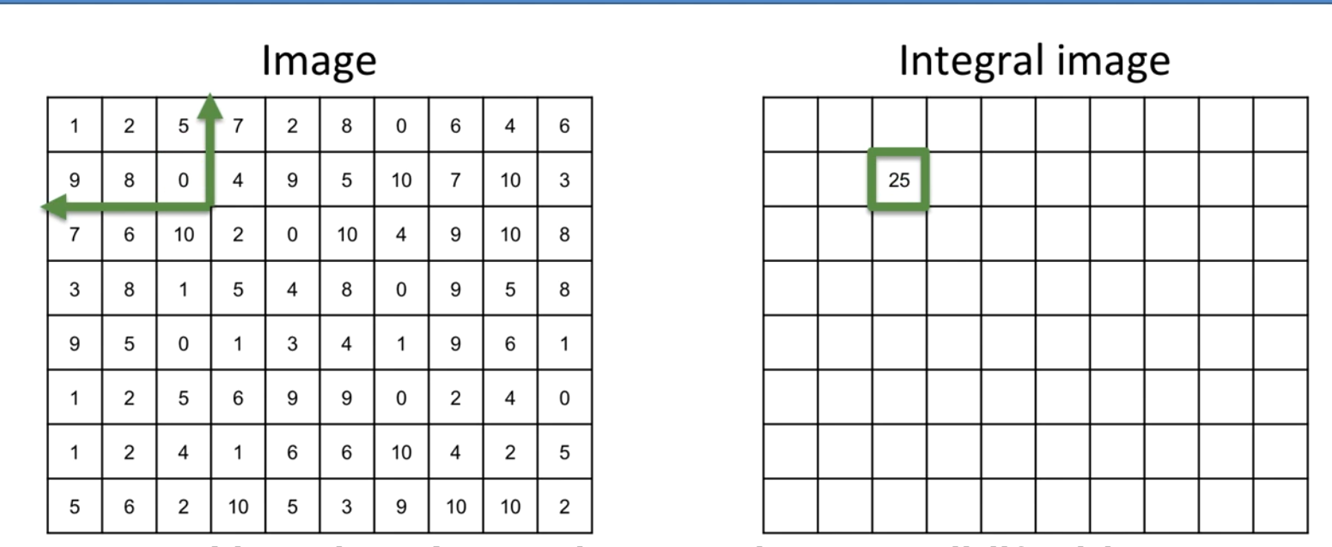

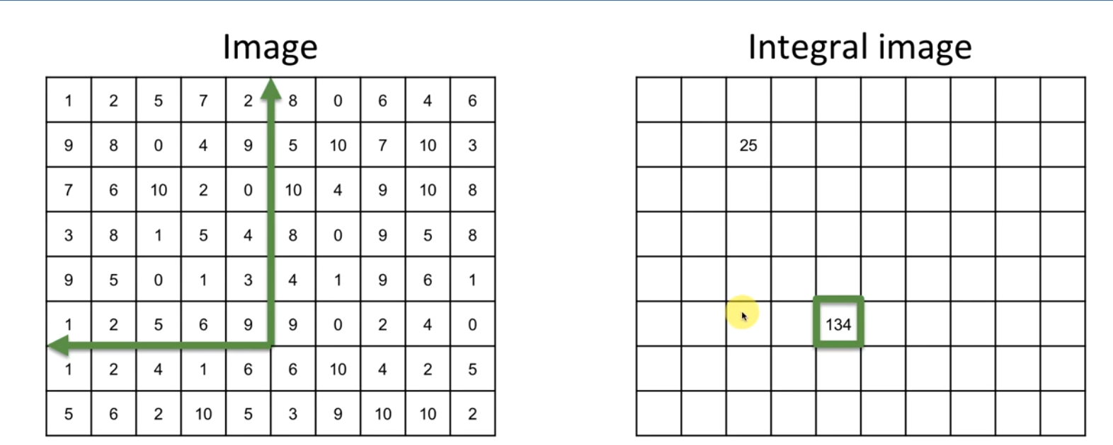

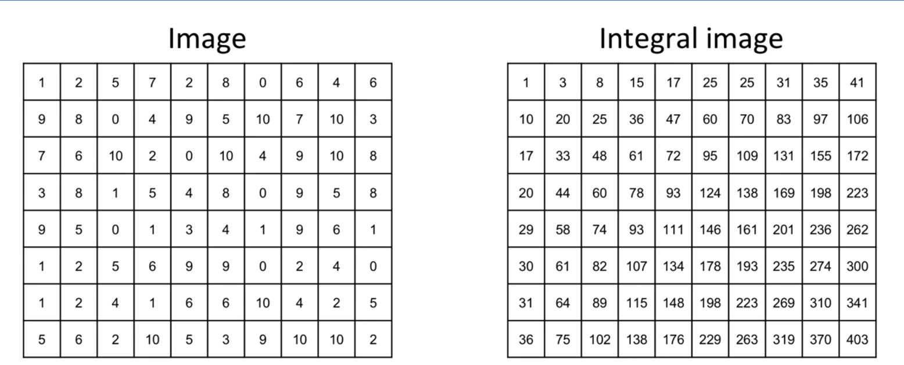

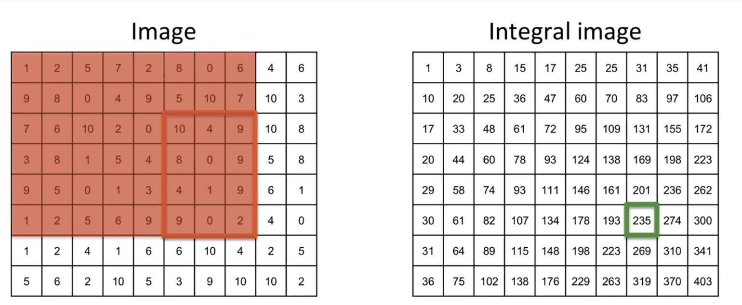

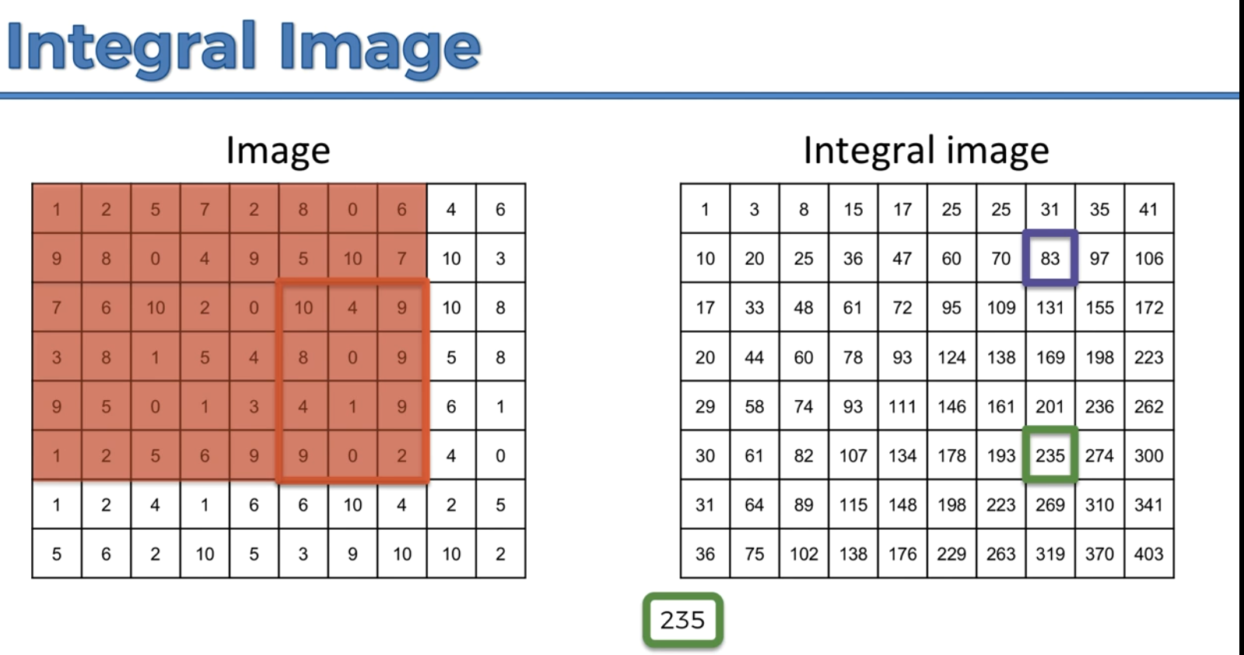

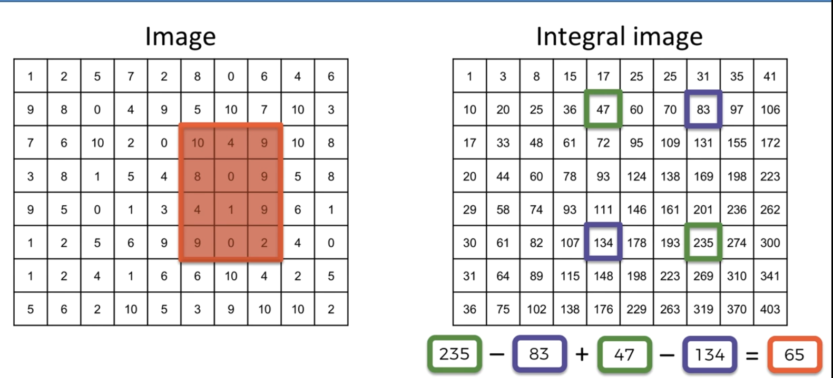

The integral image here allows us to perform only 4 operations to calculate the value of the large rectangle. And it remains the same for any size of the rectangle.

**Training Classifiers**

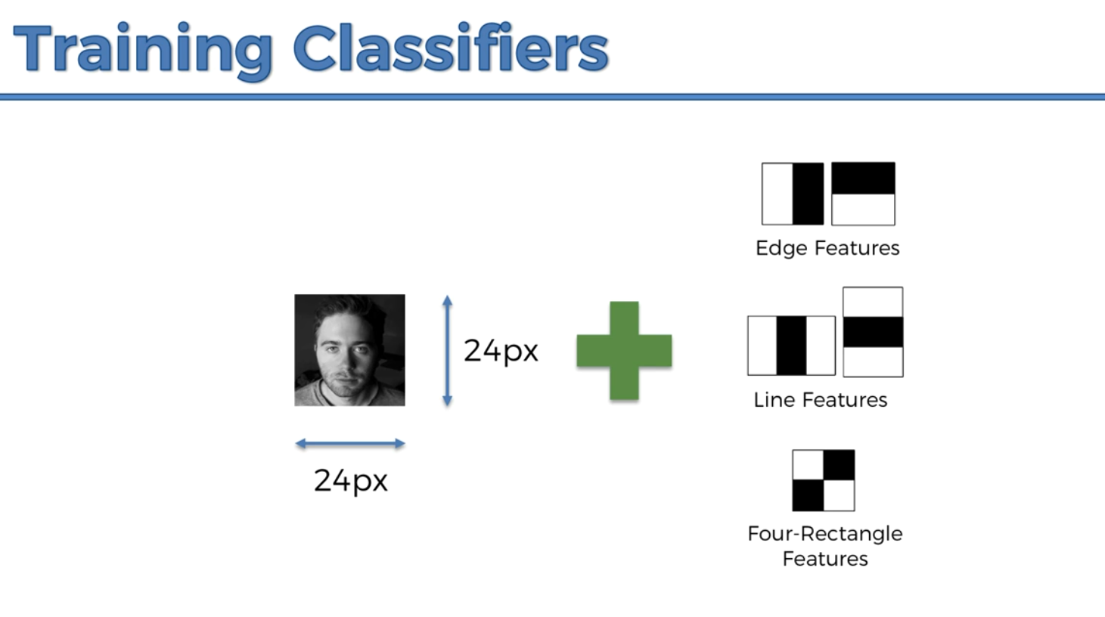

It reduces it to 24 by 24 pixels because these pixels are scalable so there’s lots and lots of different combinations of these features and it’ll take forever to look through it. So, it’s easier to scale down the image and look for the features that fit in a 24 by 24 combination. So when you’re training you scale the image down, and the features are detected there. And then when you’re detecting you scale the features up and you look for them in the image.

**NOTE: Taking a mirror image of your image data can enable you to double the amount of training data.**

Then also supply a couple of non-face images, note, they shouldn’t have faces and they don’t have to be a 24 by 24 image. And if it’s a big image you can take sub-windows (parts) of the image thus increasing the amount of data.

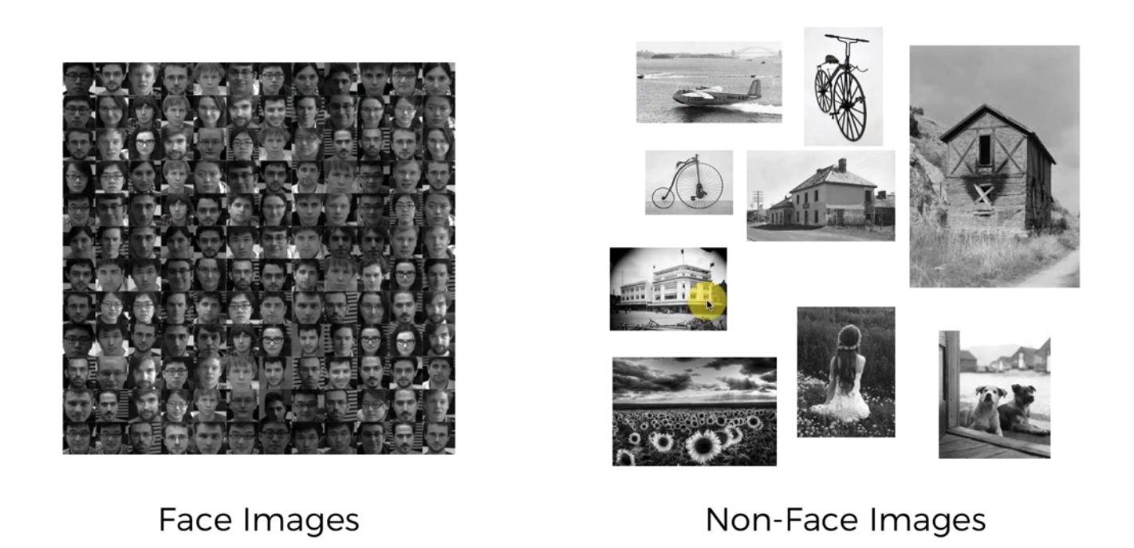

**Adaptive Boosting (Adaboost)**

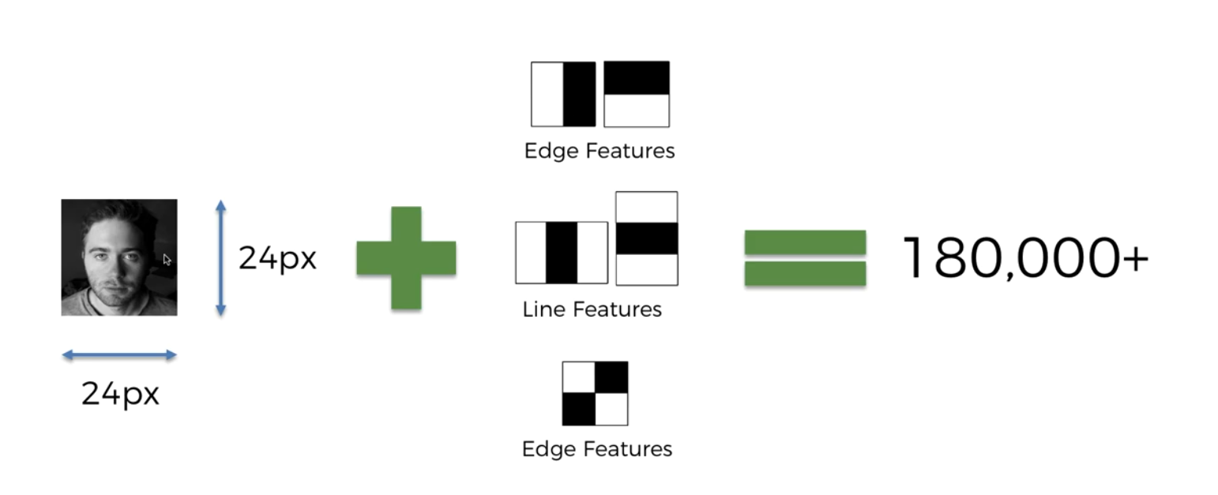

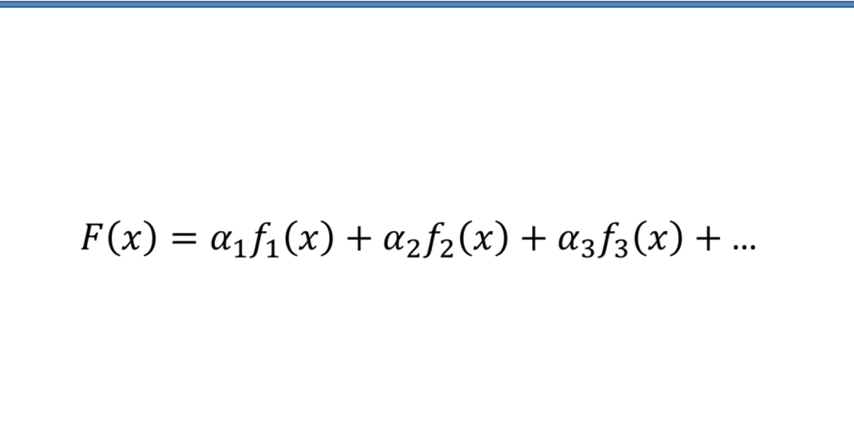

F(x) is the classifier on the left. F1, F2 and F3 are the features and alpha1, 2, and 3 are the weights of the features.

It’s an ensemble method because you’re leveraging the power of the crowd.

Adaboost involves selecting a bunch of features that compliment each other.

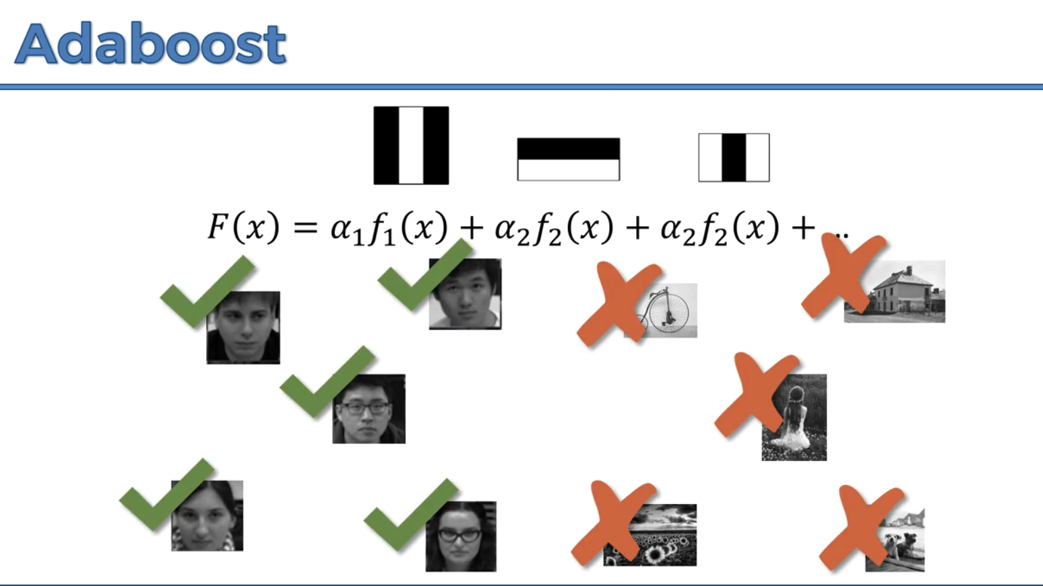

**CASCADING**

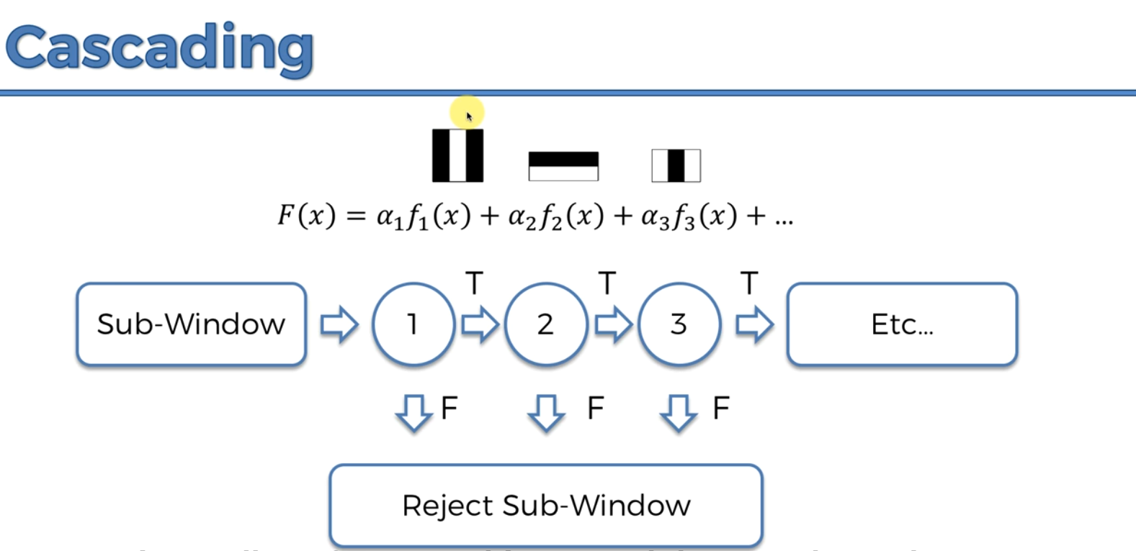

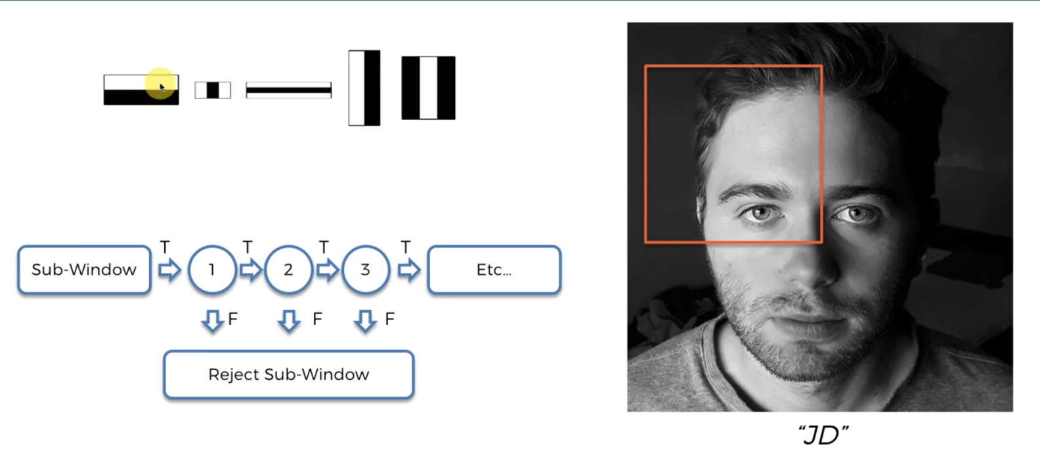

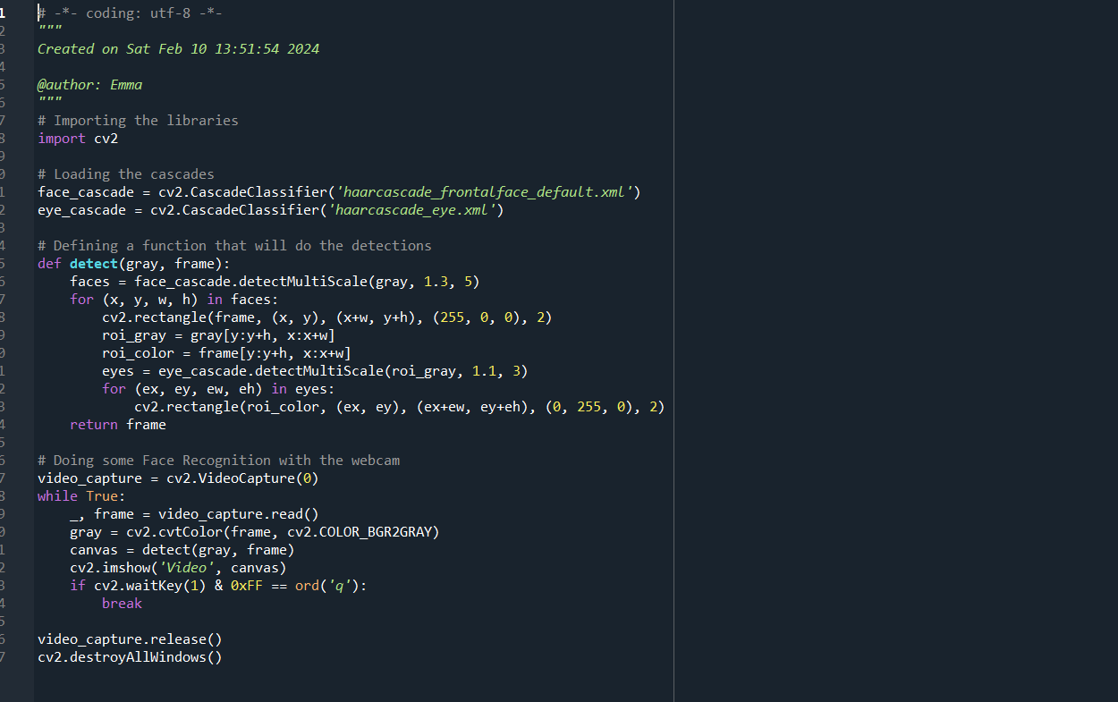

**Note:** OpenCv is not based off neural networks hence it’s not deep learning.

Cascade is a series of filters that you apply one at a time to detect the face.

In the detectMultiScale function the scale factor of 1.3 is how small the image will be reduced and the minimum number of neighbors is the least number of neighbor zones that should be also excepted and 5 is a good number.

Faces are tuples of 4 elements, x and y which are coordinates of the upper left corner of the rectangle that will detect the face and w, z which is the size of this rectangle.

cv2.rectangle(frame, (x, y), (x+w, y+h), (255, 0, 0), 2) is for creating the rectangle for detecting the face.

(x+w, y+h) is the bottom right corner of the rectangle, (255, 0, 0) is the color of the rectangle which is blue, and 2 is the thickness of the rectangle.

roi_gray = gray[y: y+h, x: x+w] – is the region of interest inside the rectangle detecting the face e.

video_capture = cv2.VideoCapture(0) – the argument 0 is if it’s the internal camera of the computer and 1 if you’re getting the video from an external webcam.

gray = cv2.cvtColor(frame, cv2.COLOR_BGR2GRAY) takes the original color image and converts it into its gray format.

**Note: If you want to find haarcascades go to OpenCV haarcascade on Google.**

**SINGLE SHORT MULTIBOX DETECTION ALGORITHM (SSD)**

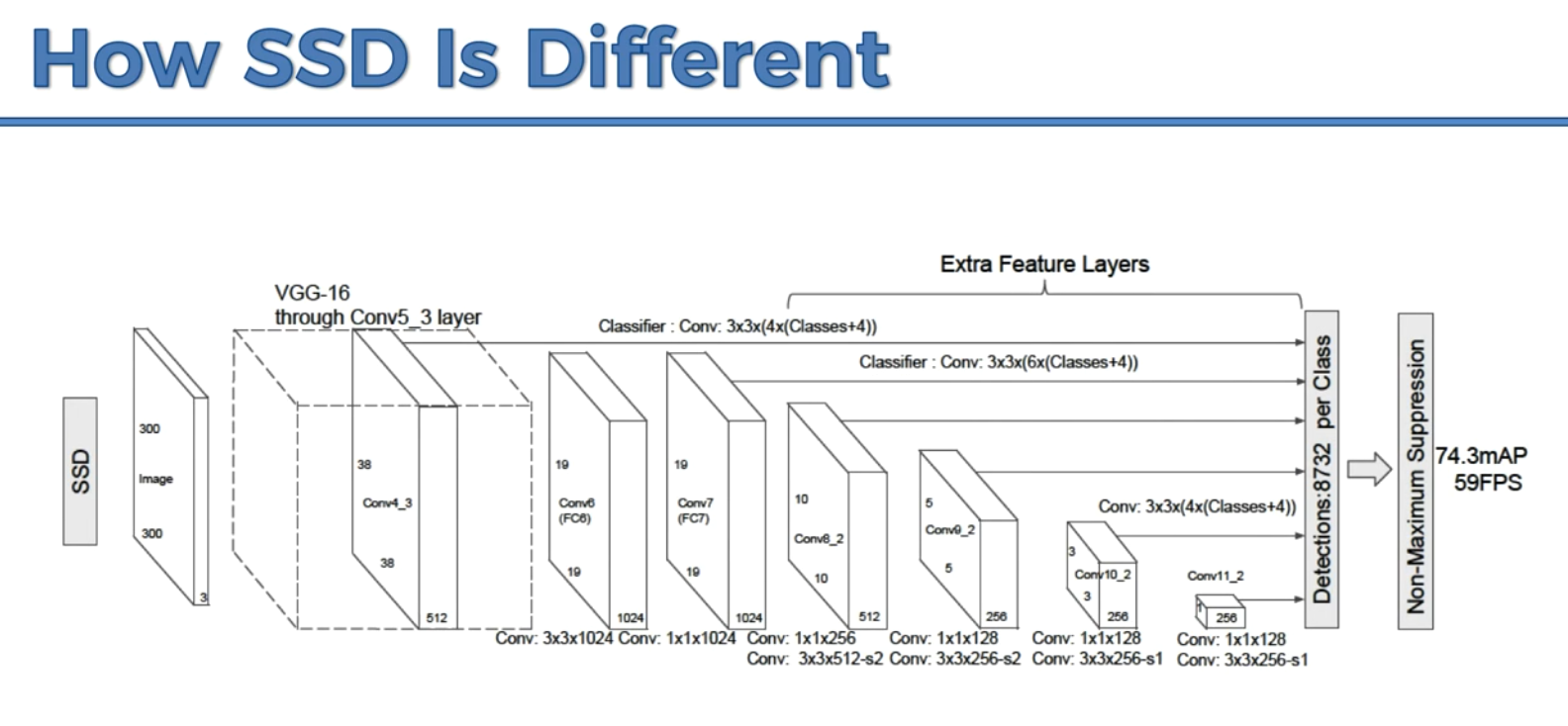

Note: YOLO stands for You Only Look Once. Apart from YoLo and SSD there’s no other algorithm that only looks at the image once, well at this time.

**The Multi-Box Concept**

**Ground truth –** separates the empirical evidence from the observed evidence.

It involves breaking the image into segments and constructing boxes for each segment. Then for every single one of the boxes, it’s going to ask itself is there an object there for which I’m looking there.

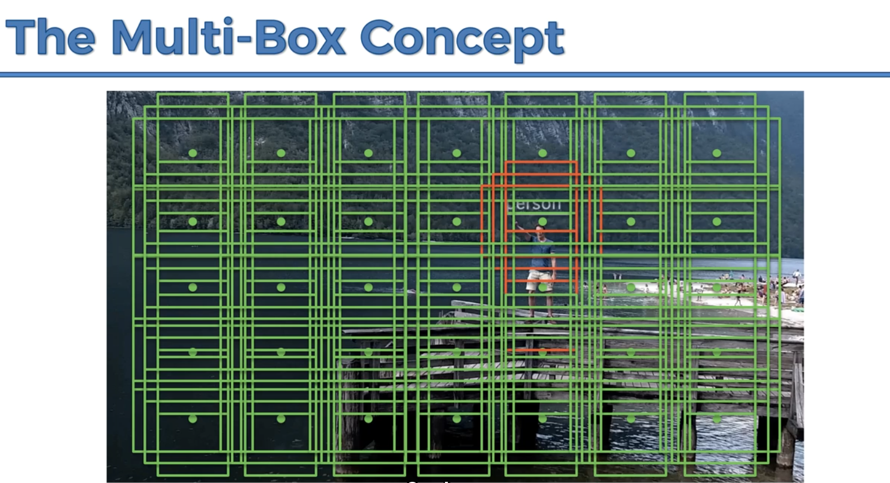

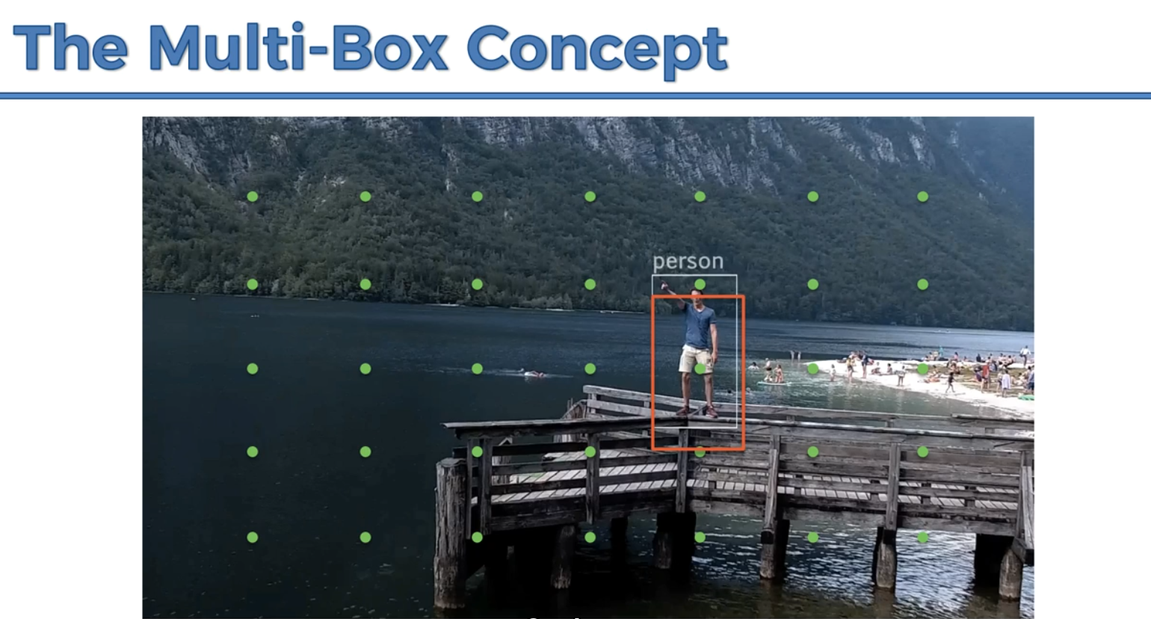

It doesn’t have to be a full person or object, as long as it finds a sufficient number of features it’ll produce a probability that confirms the desired object.

When an error is detected-the result is against the ground truth, it’ll be backpropagated through the network and the weights for that feature will be updated.

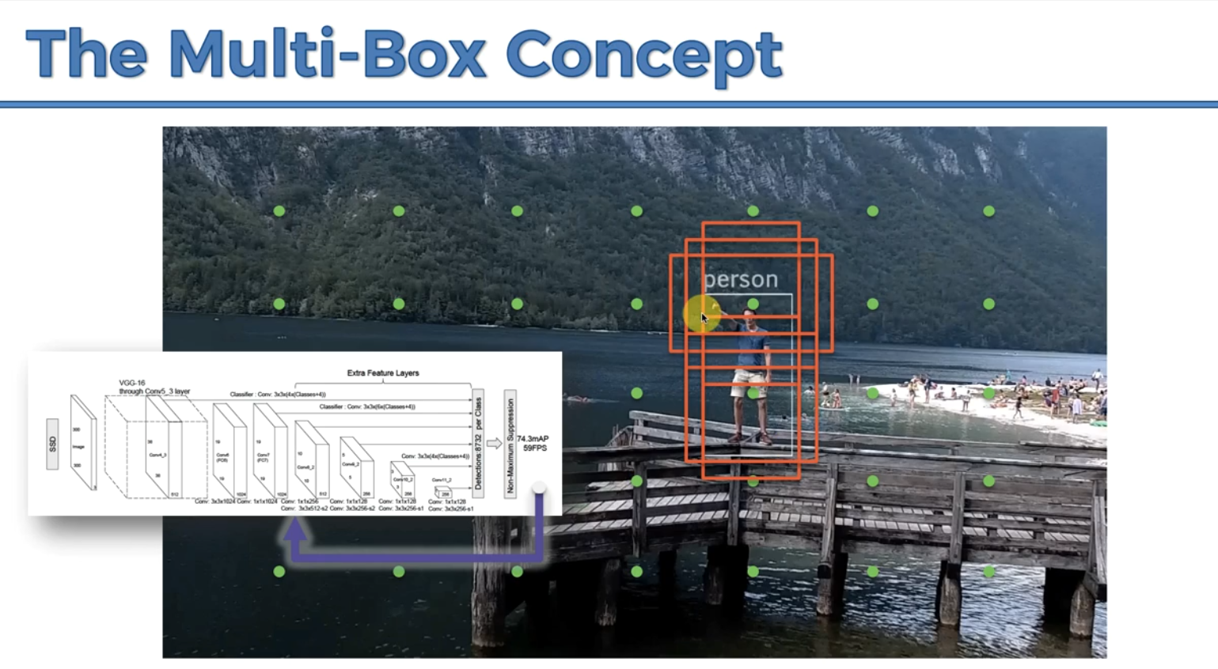

**Predicting Object Positions**

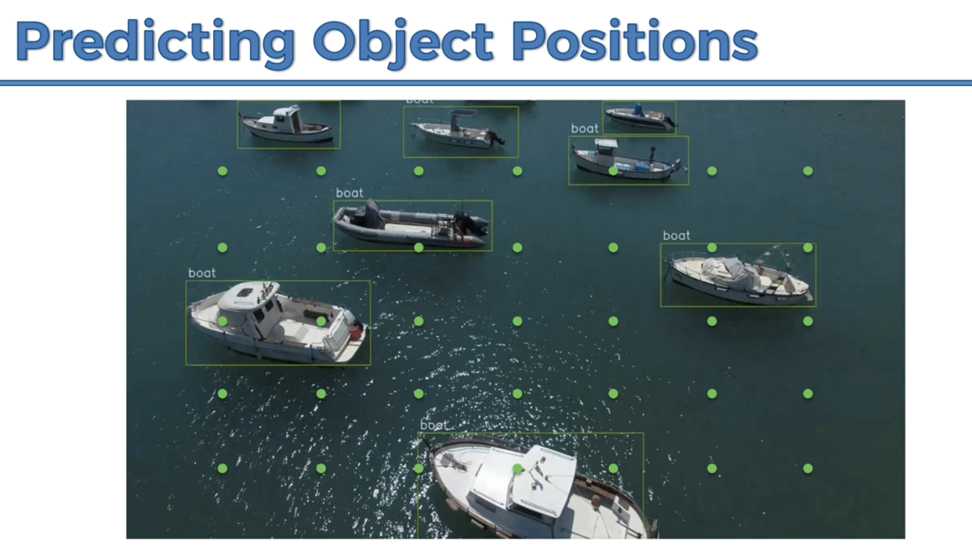

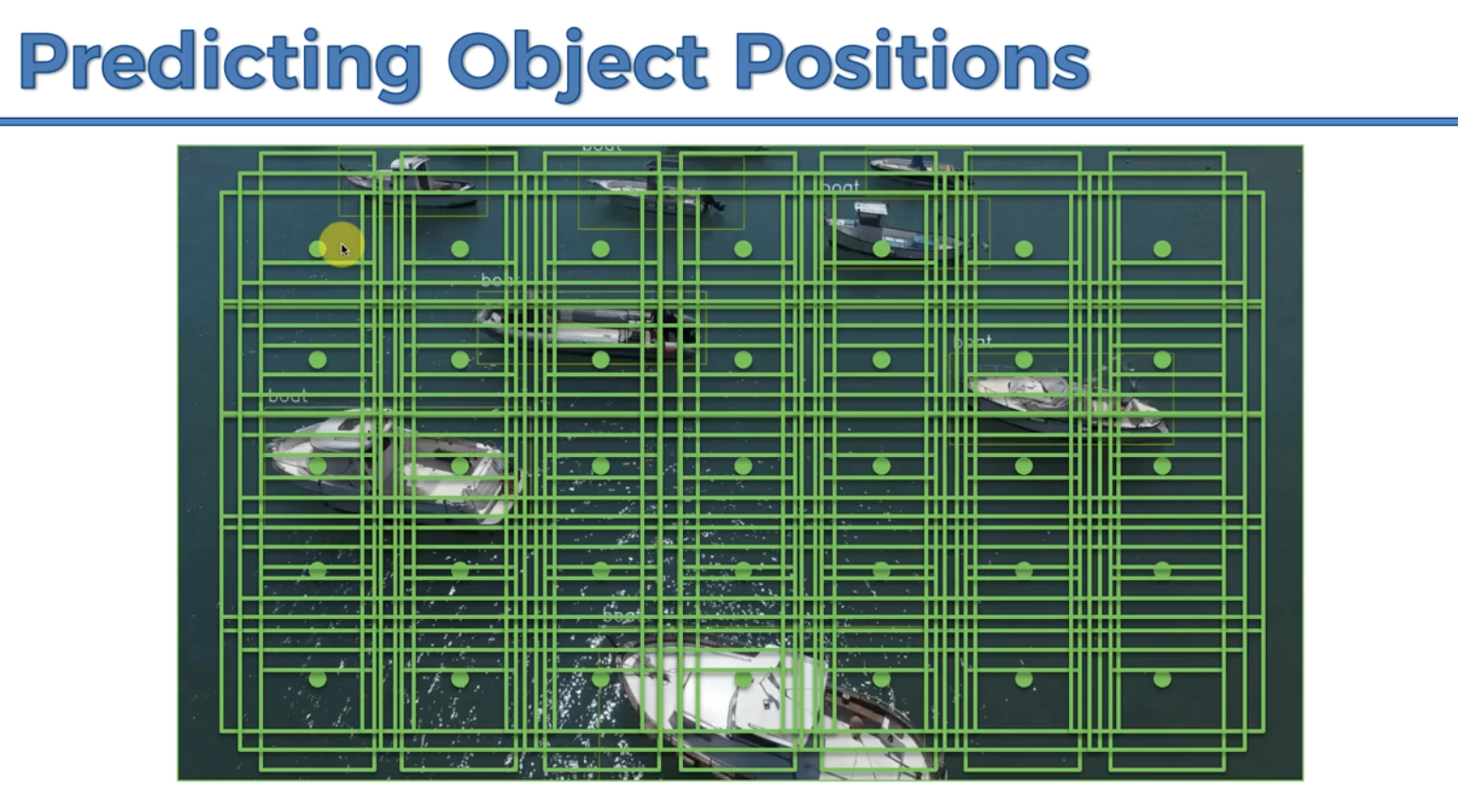

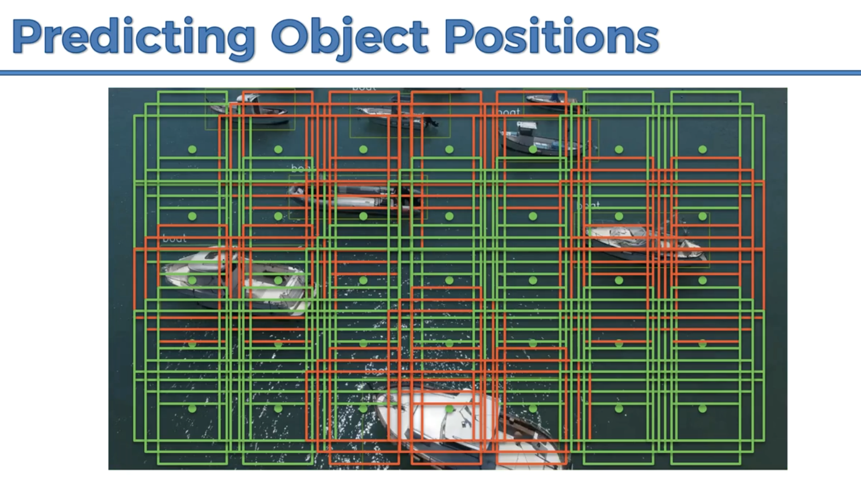

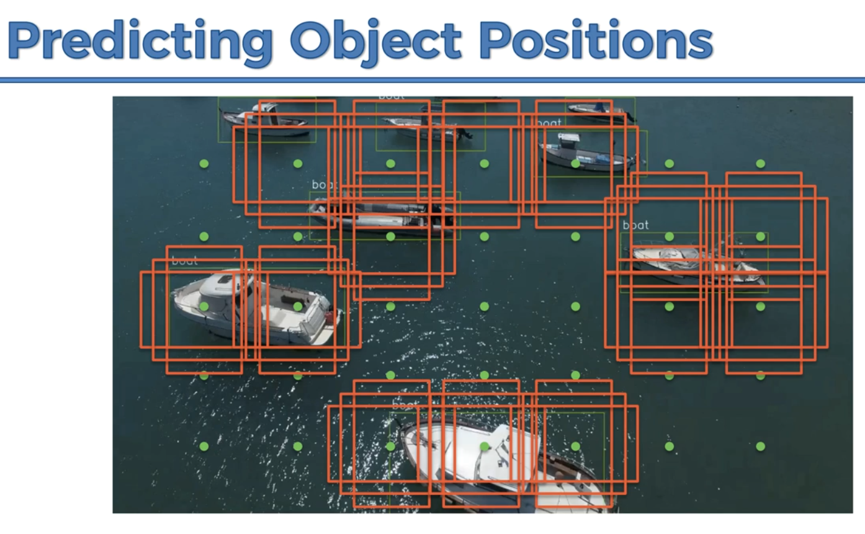

**The Scale Problem**

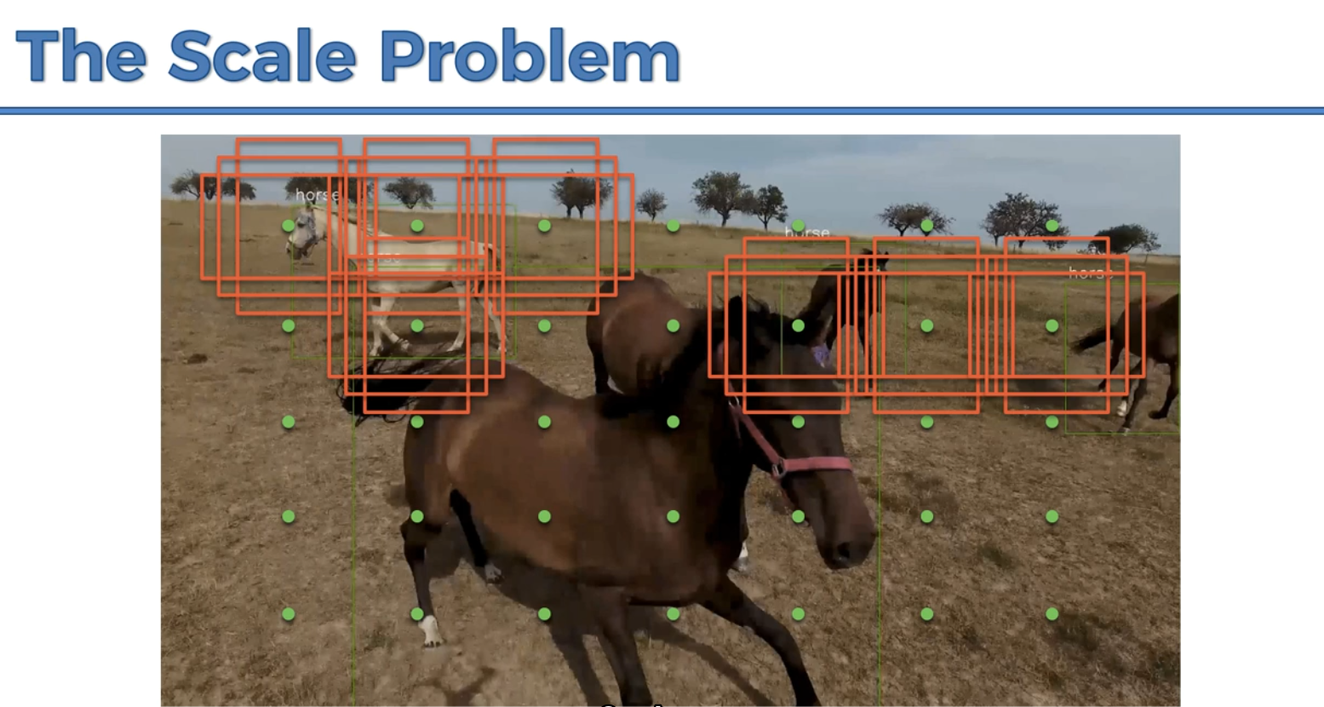

The horse is too big for the algorithm to pick up.

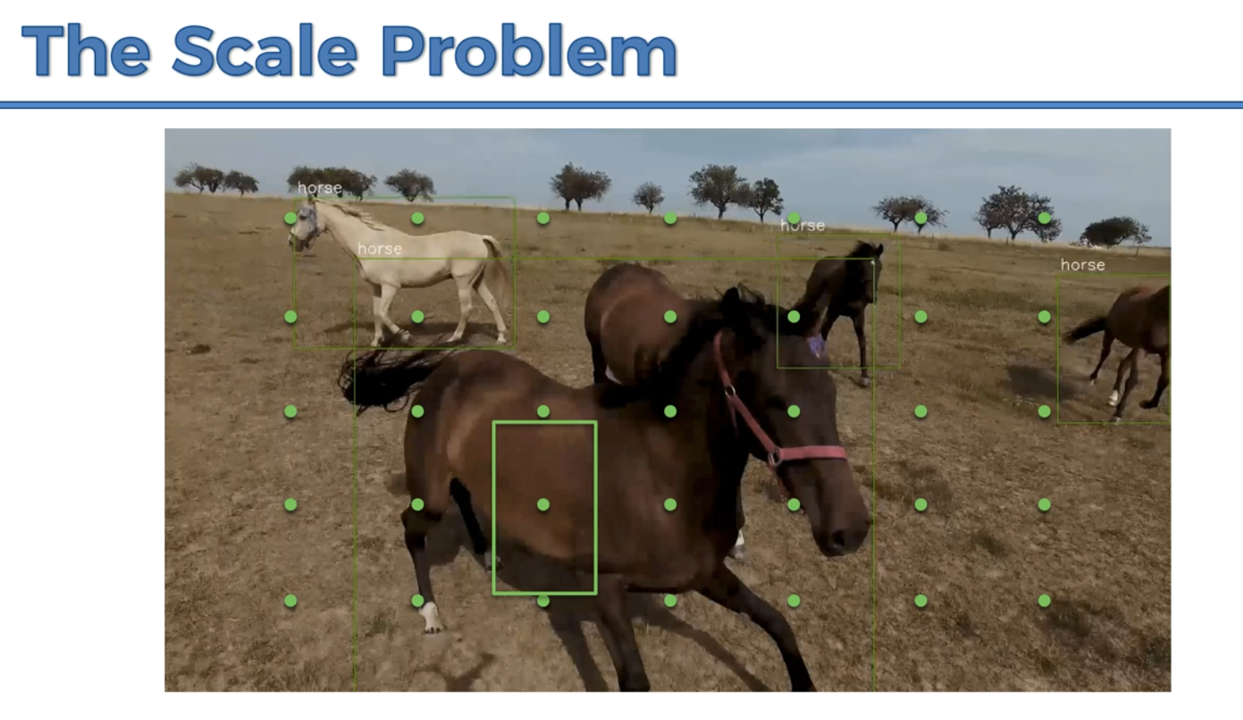

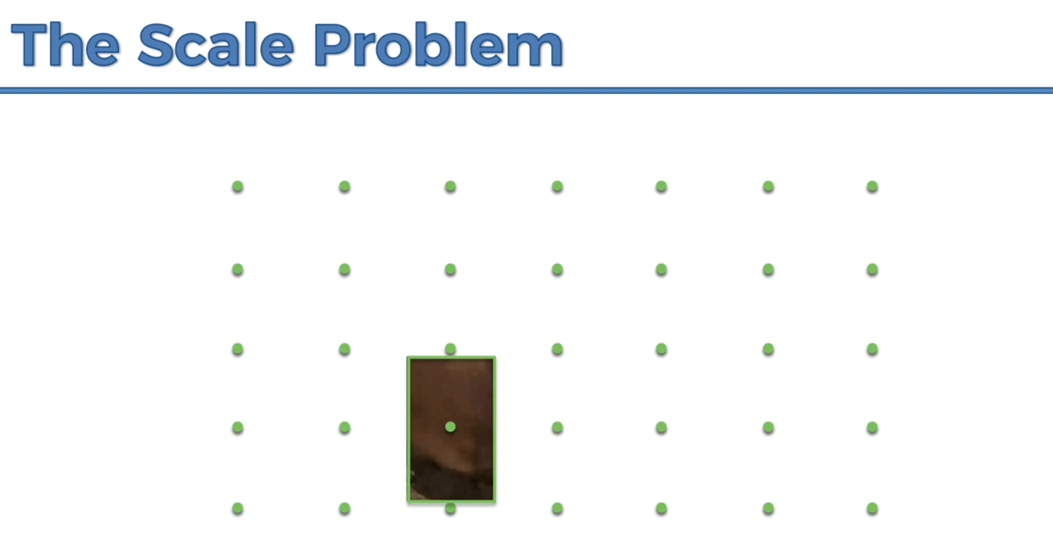

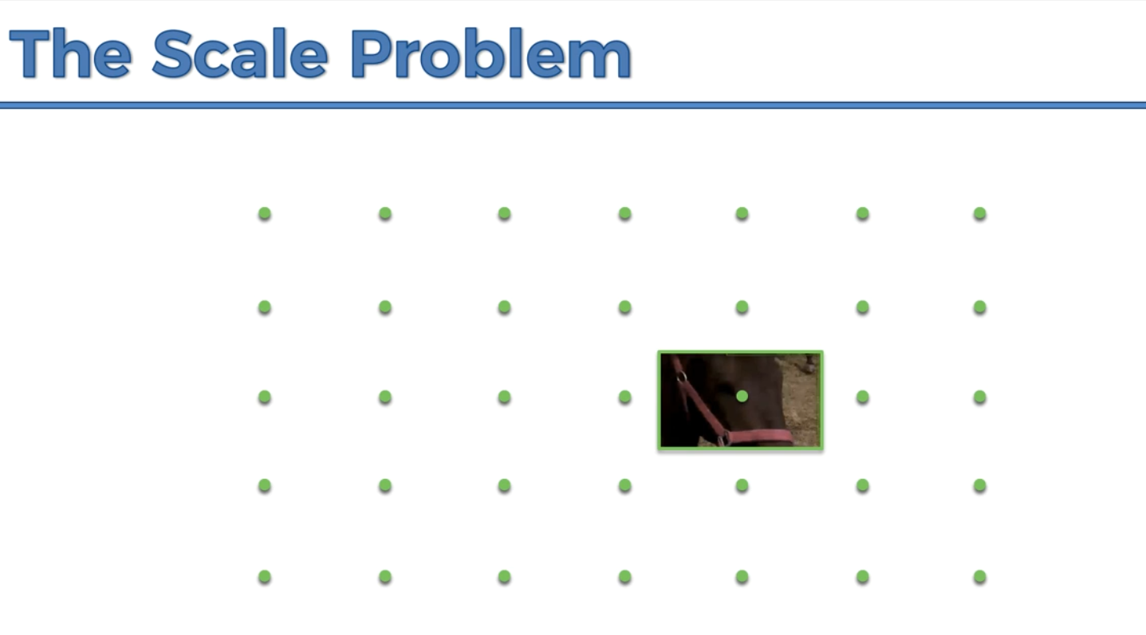

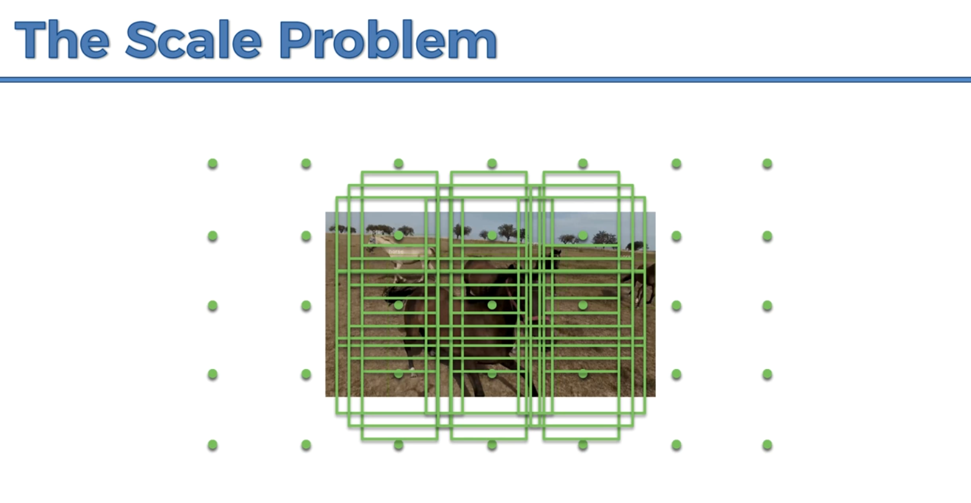

In the actual case the image is not just resized but also goes through a convolution which preserves the features.

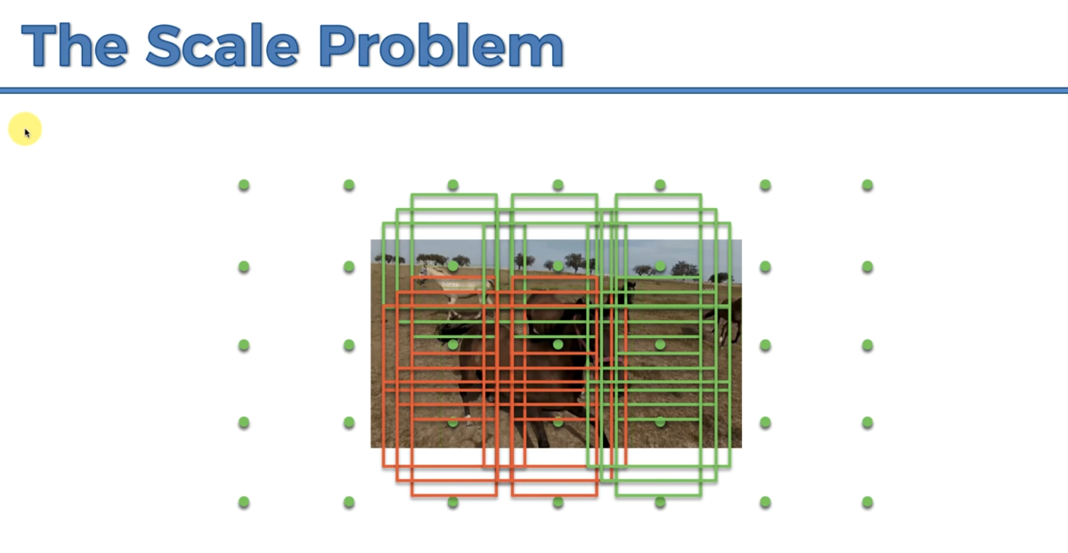

Pytorch is very good when computing the gradients of the composition functions to update the weights. It contains dynamic graphs which enable fast computations of these weights.

cv2 is used to draw the rectangles around the needed object but it’s not used in the SSD implementations

BaseTransform is a class that does required transformations such that the input images are in the required format of the neural network.

Variable class converts a torch variable into a torch sensor.

VOC_CLASSES is a dictionary that does the encoding of the text fields of the class.

ssd is the library of the single short multibox detection model.

imageio is a library used to process the images of the videos and applying the detect function to implement on the images instead of using PL library.

x = torch.from_numpy(frame_t).permute(2, 0, 1) – the permute function allows you to change the images from red blue green to green red blue which was the format the SSD model was trained.

The neural network cannot accept single inputs or single images, it only accepts batches of inputs.

In pytorch, the unsqueeze function will always be before fitting the input.

x.unsqueeze(0) – zero is the index of the input image of the first dimension corresponding to the batch that we’re adding to our structure of input images.x = Variable(x.unsqueeze(0)) - A torch variable is a highly advanced variable that contains a tensor and a gradient.

scale = torch.Tensor([width, height, width, height]) The first width, height, corresponds to the upper right corner of the rectangle and the second one corresponds to the lower right corner of the rectangle. And we’re doing it to normalize the scale of values of the position of the detected objects between 0 and 1.

detections.size(1) – is the number of classes.

while detections[0, i, j, 0] – the first zero is the batch zero that has index zero, j is the occurrence of the class i, and the last zero is the score.

pt = (detections[0, i, j, 1:]) – 1:0 is obtaining the coordinates x0, y0, x1, y1

pt[0], pt[1], pt[2], pt[3] are x0, y0, x1, y1

transform = BaseTransform(net.size, (104/256.0, 117/256.0, 123/256.0)) - net.size is the target size to be fed into the neural network.

**NOTE: To train your SSD, you have to have CUDA** on your PC. If you train it without CUDA it will take several months. You cannot train it on CPU, you can only train it with an NVIDIA graphics card on your machine that has CUDA.

**Generative Adversarial Networks**

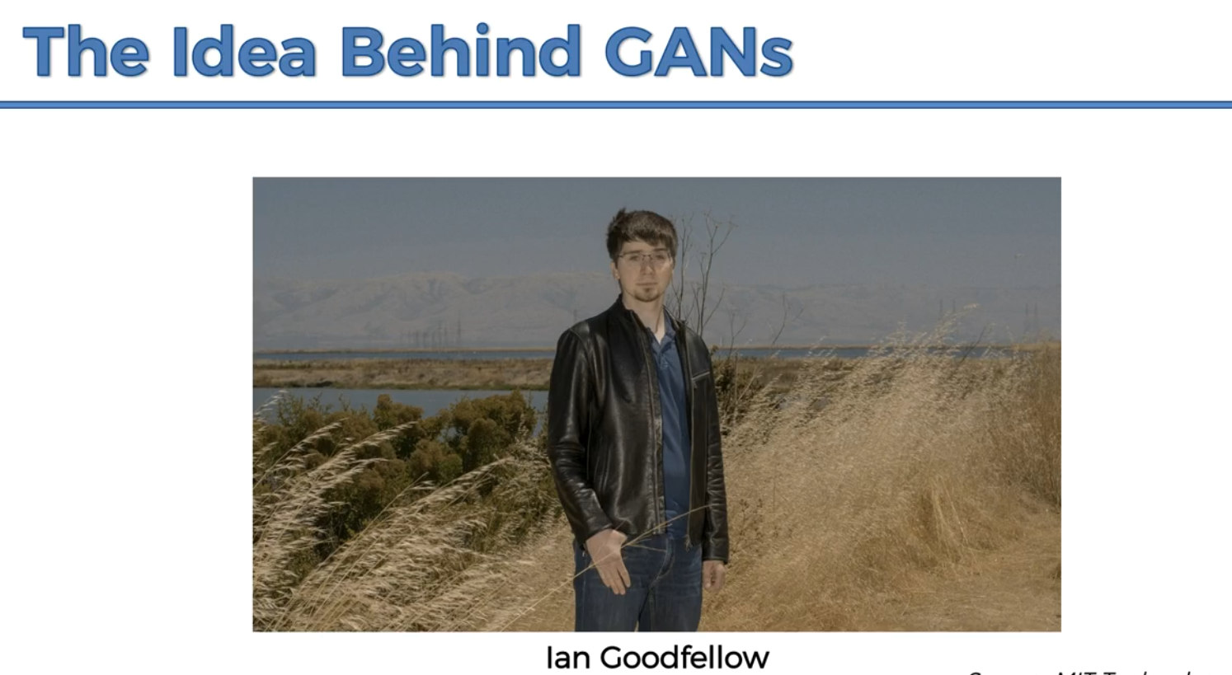

Created by Dr. Ian Goodfellow, only 31 years old. Works at OpenAI as a researcher.

GANs work on generators and discriminators. The generator generates the image and the discriminator determines whether the generated image resembles a real world ever seen before image.

The generators is always trying to full the discriminator and the discriminator is the one that has the actual realistic images. They’re supposed to grow together. Individually they are fighting together but as a whole the entire network is growing together.

<https://hackernoon.com/how-do-gans-intuitively-work-2dda07f247a1>

**How Do GANs Work?**

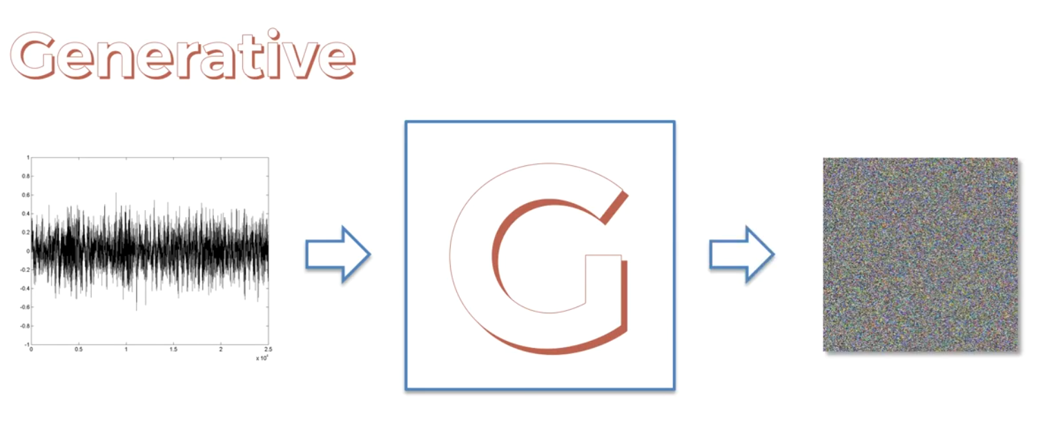

The generator takes in a random noise input and outputs an image.

The discriminator is another model rivaling the generator aka detective. It’s capable of learning lots of features of various classes.

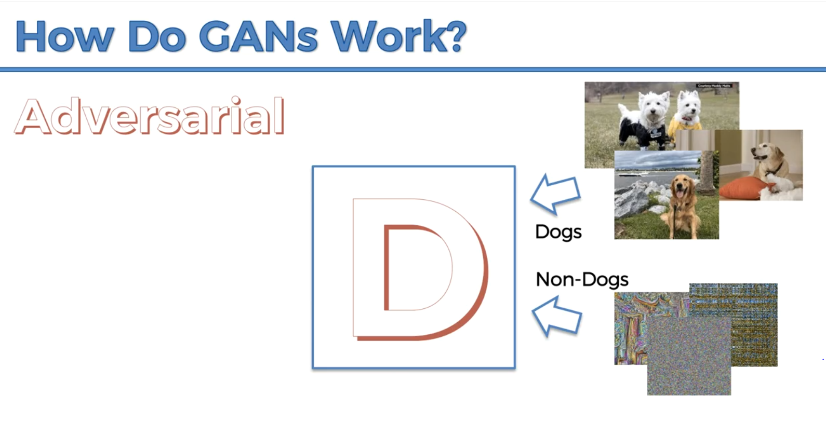

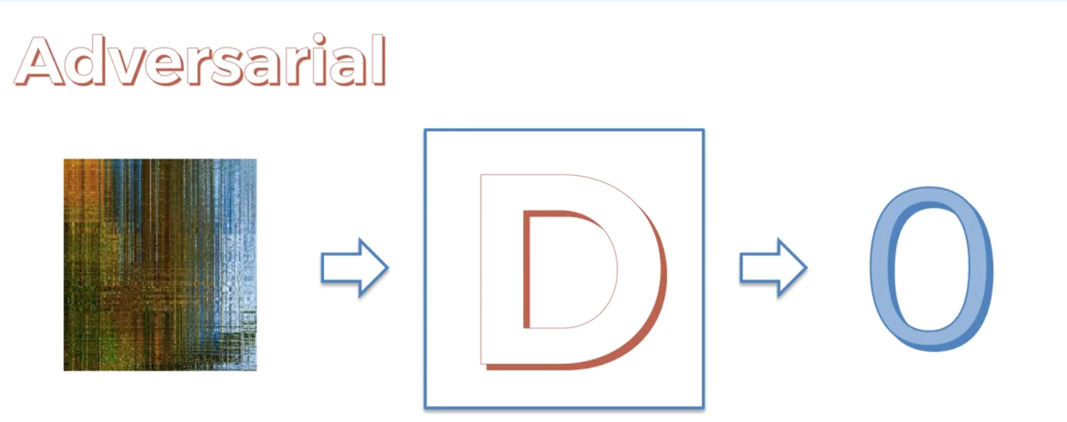

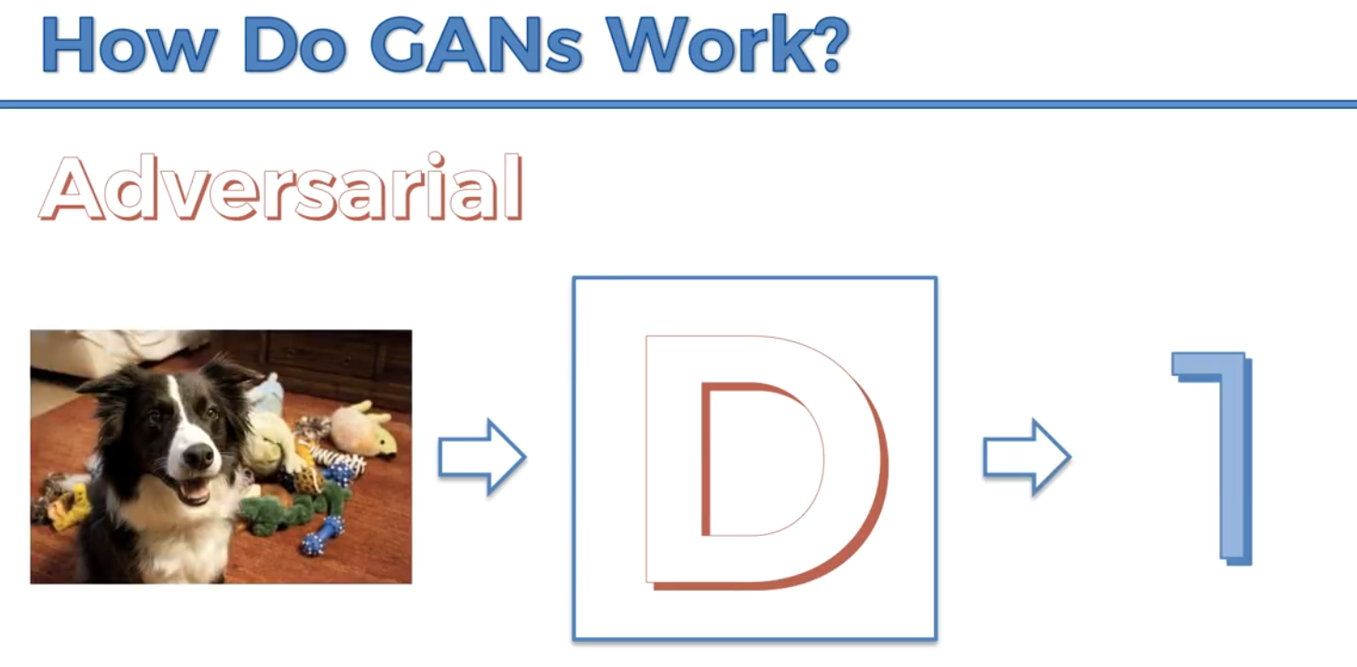

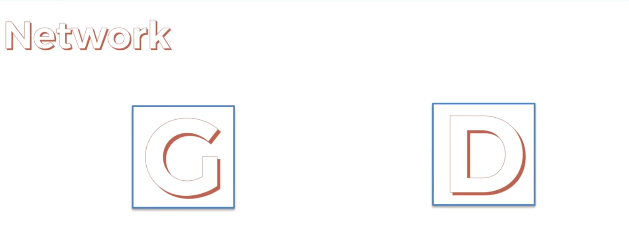

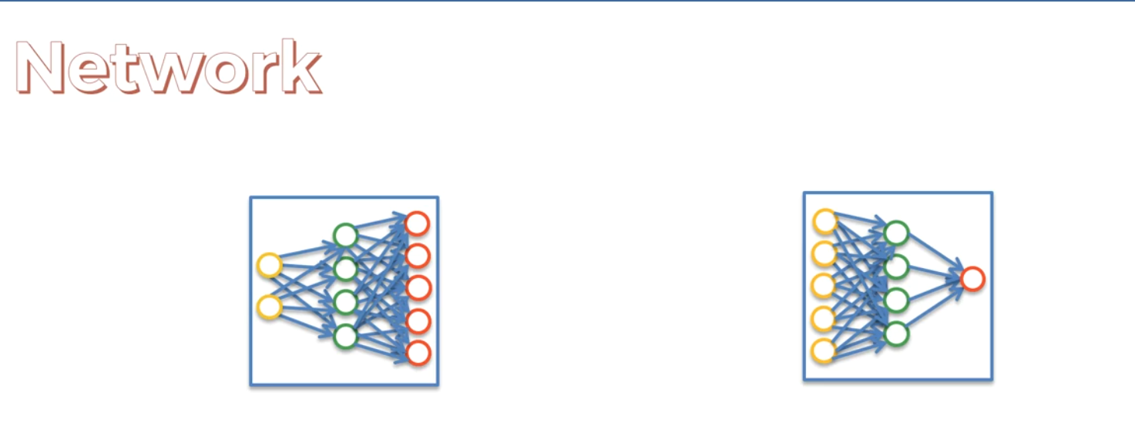

**Step 1**

Input the random noise signal into the generator. Then it generates some images. And we want to train the discriminator.

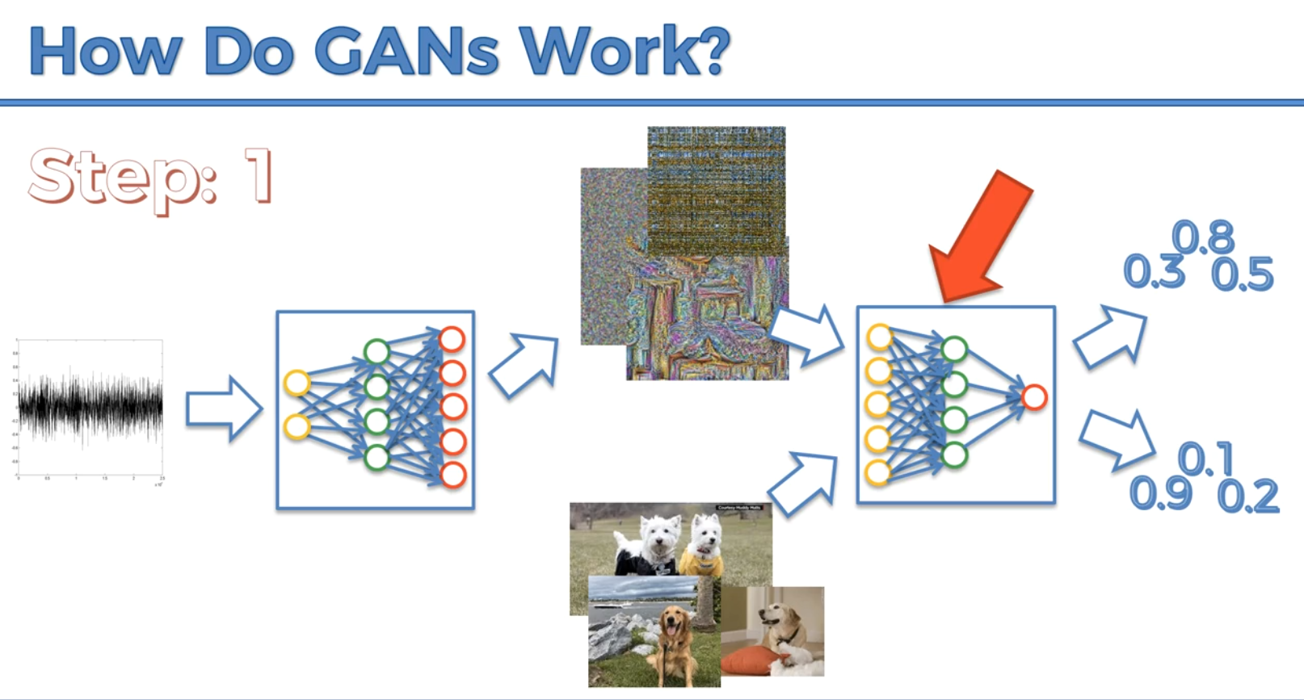

Based on the initial configuration it will give the images some probabilities.

Then we take the values and look at what they should have been i.e. the top values should be zeros and the bottom values should be ones in an ideal scenario. The error will then be calculated. And backpropagated through the network of the discriminator and the weights of the network are updated.

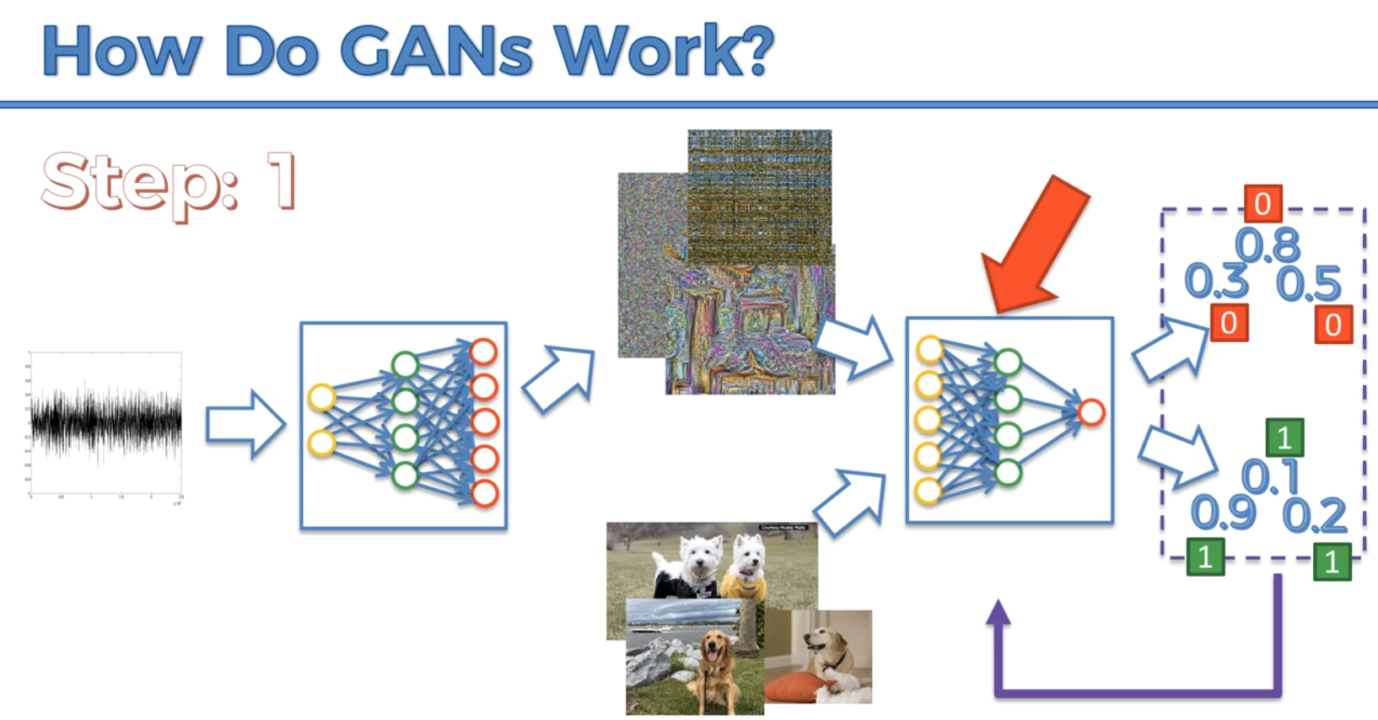

Then in training the generator, we take the same image that we’ve created and pass it as noise to the generator. And this time we don’t need to compare to any dogs or non-dogs. It’s only purpose now is to try to trick the discriminator.

We take the new values and compare them to what the should have been i.e. 1. The difference between each value and 1 will be calculated and it’ll take the aggregate error and that error will be backpropagated through the network of the generator.

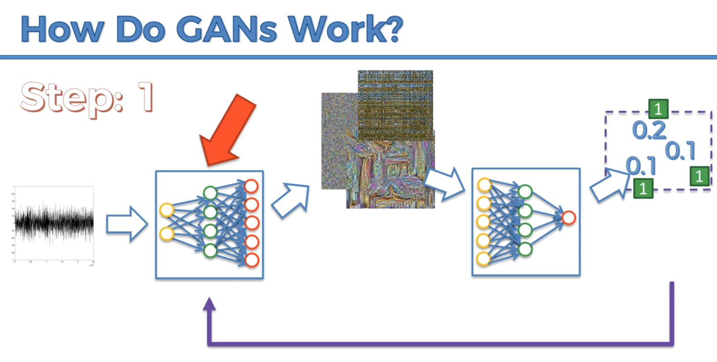

**Step 2**

Noise goes into the generator, generator generates more clear images. Then we want to train the discriminator again, that means we’ll need a batch of actual dogs. And later the discriminator will calculate the error and backpropagates the error through its network.

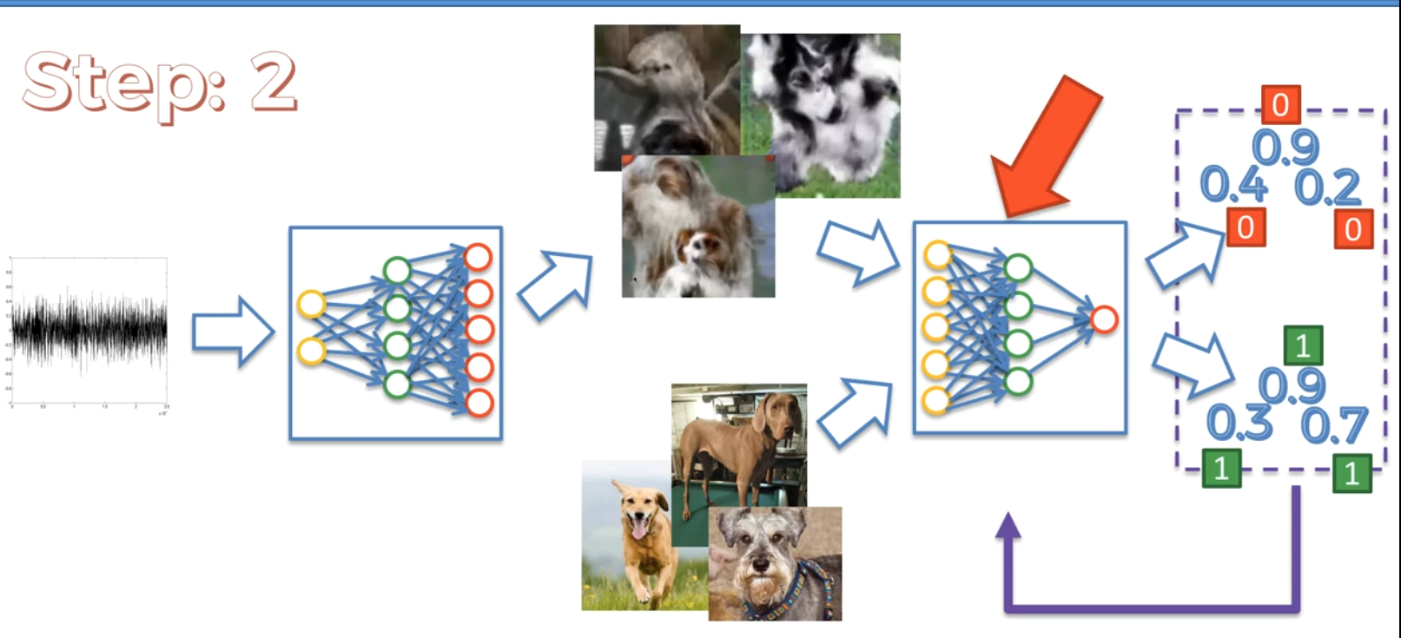

Then train the generator

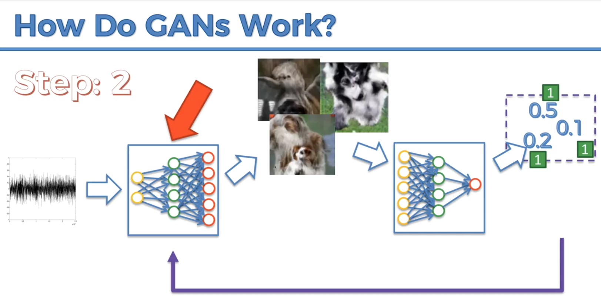

**Step 3**

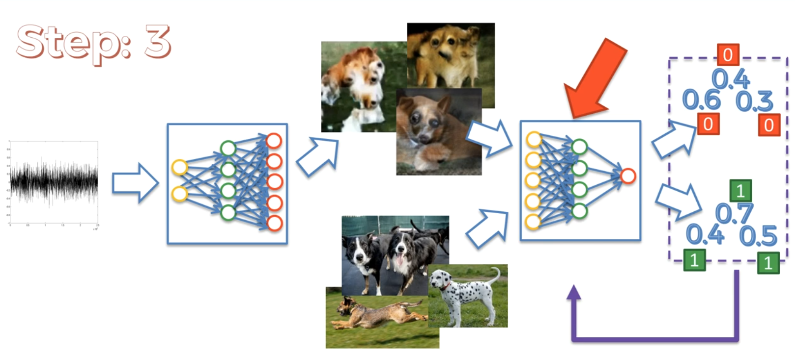

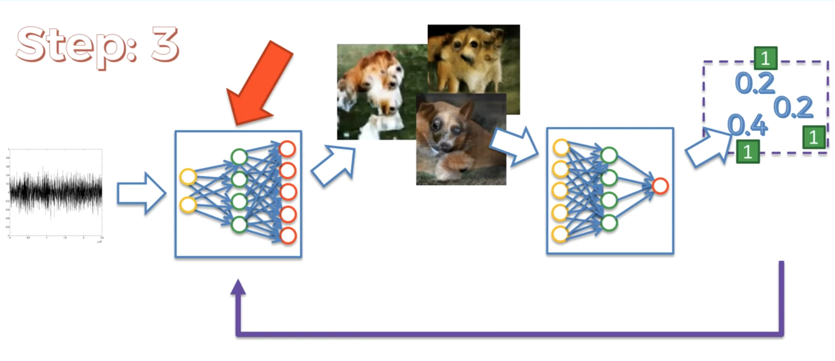

Below is a convolutional neural network

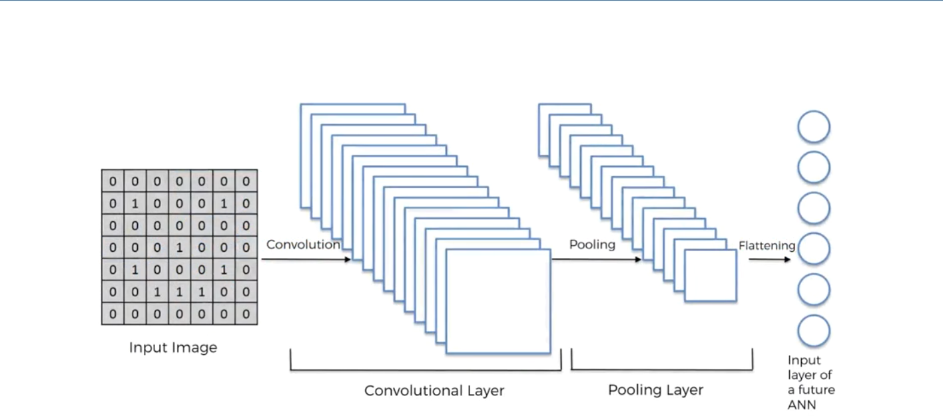

A GAN relies on a Deconvolutional Neural Network as shown below:

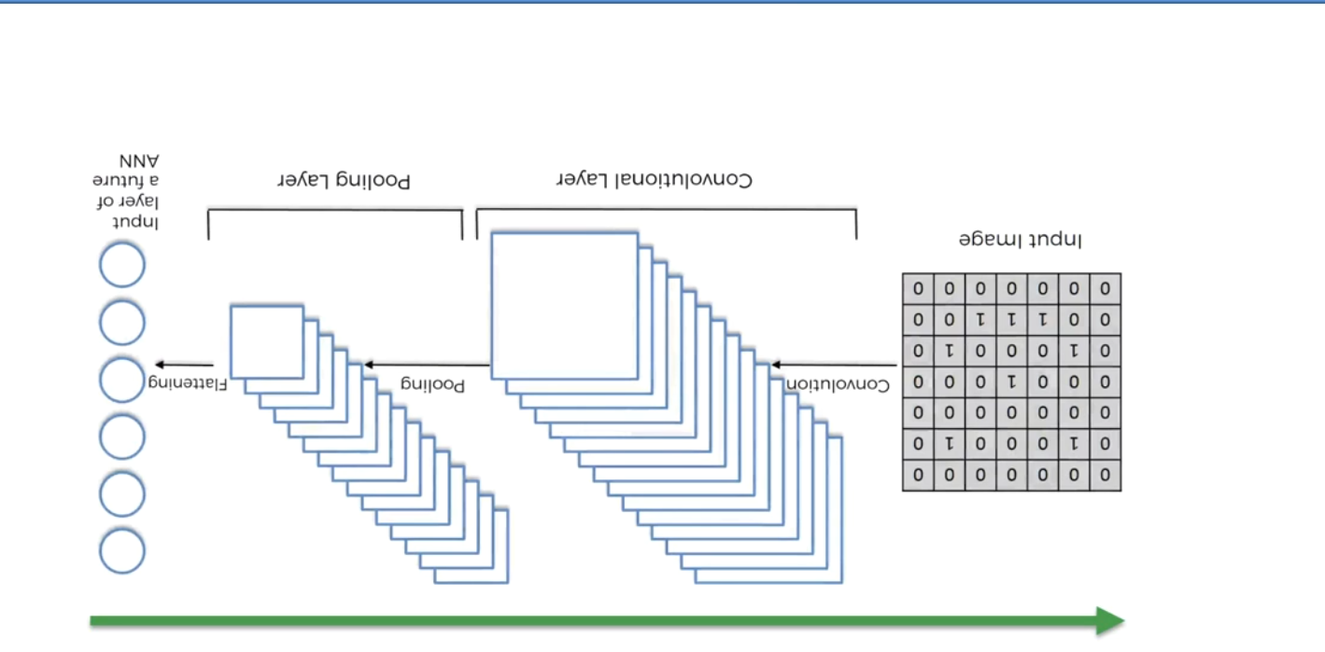

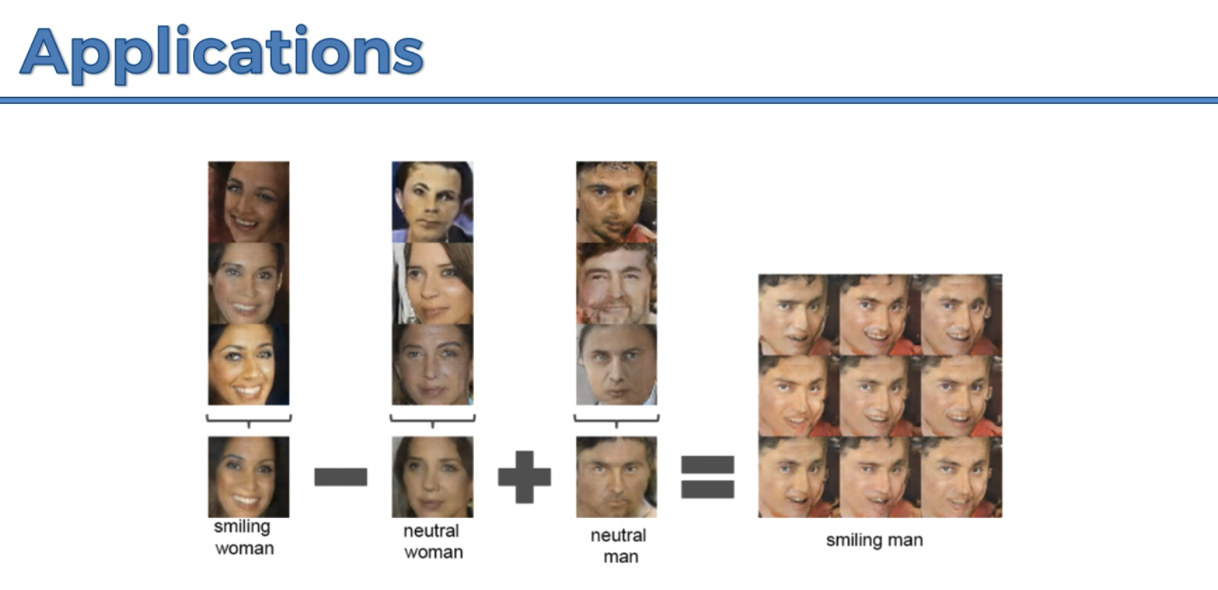

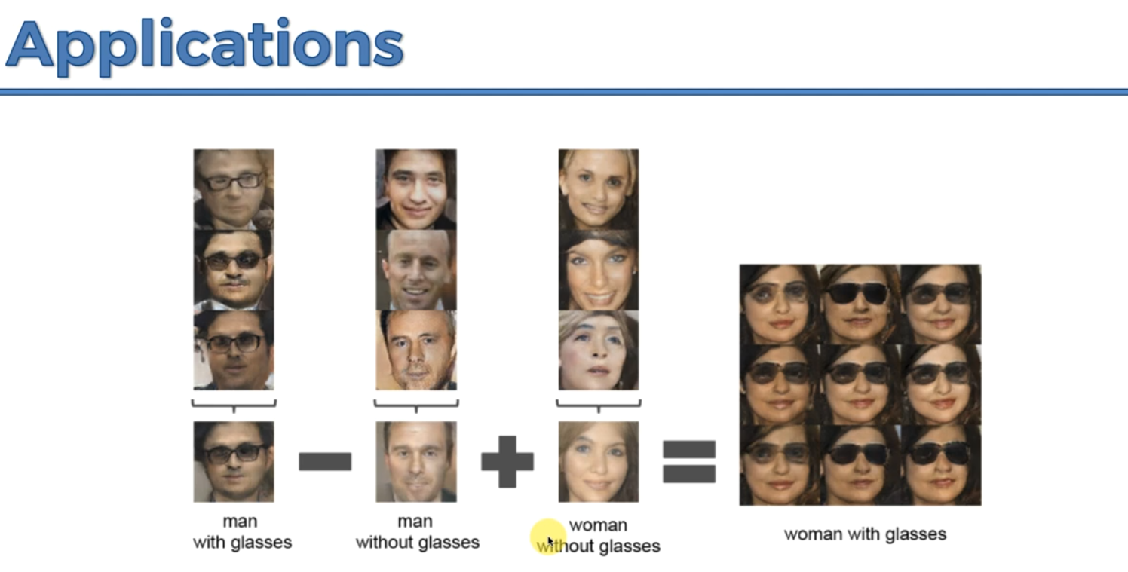

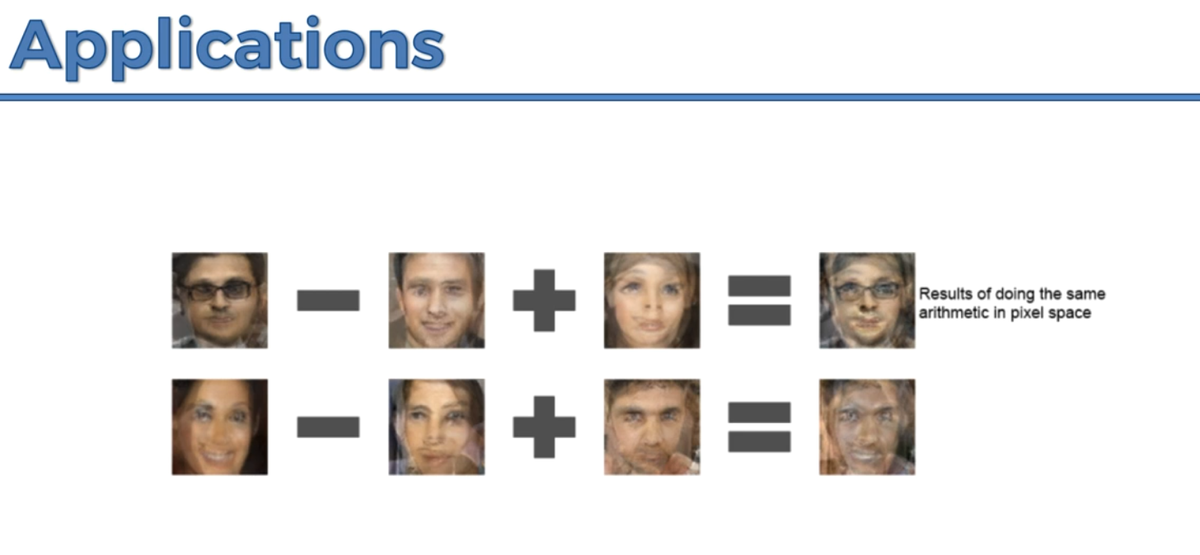

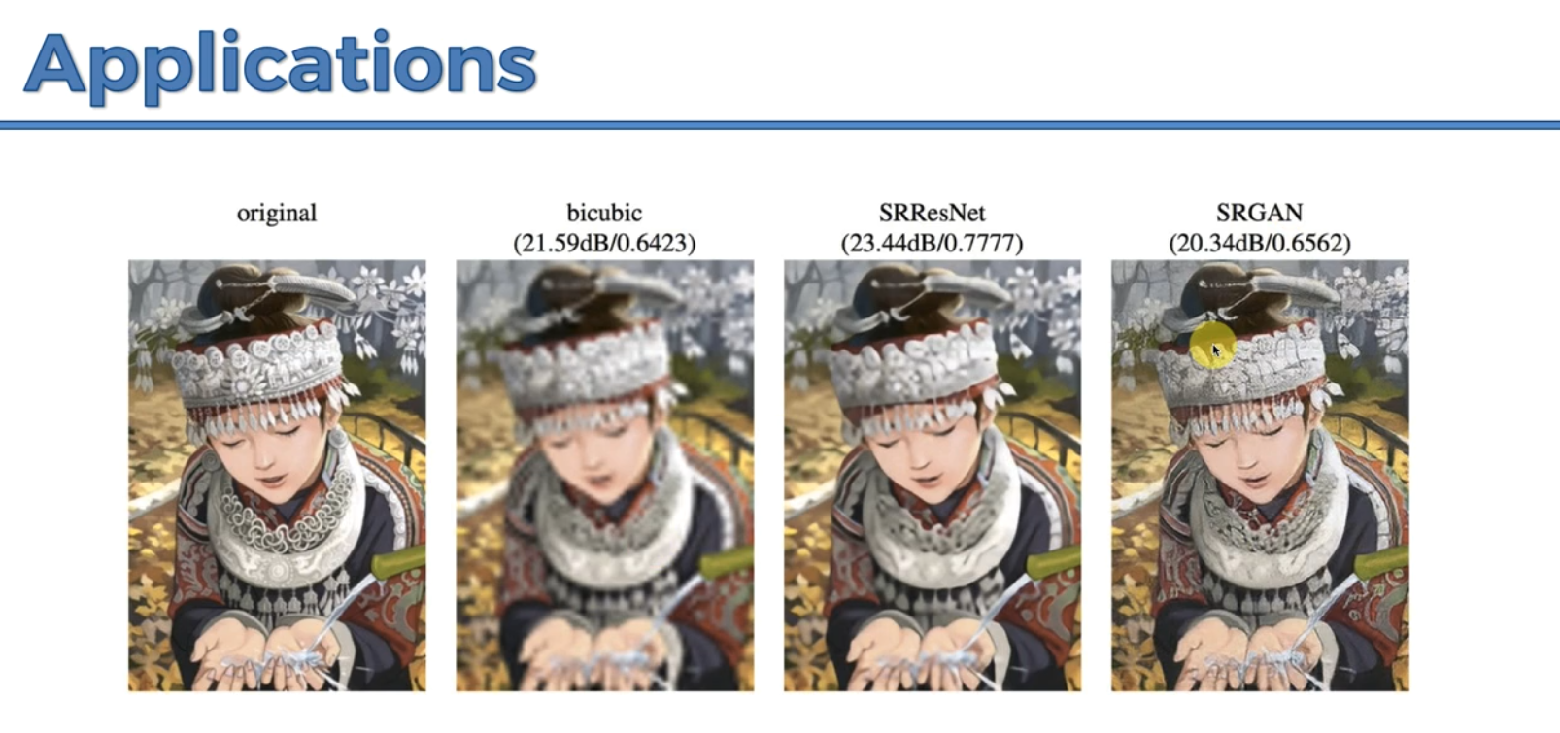

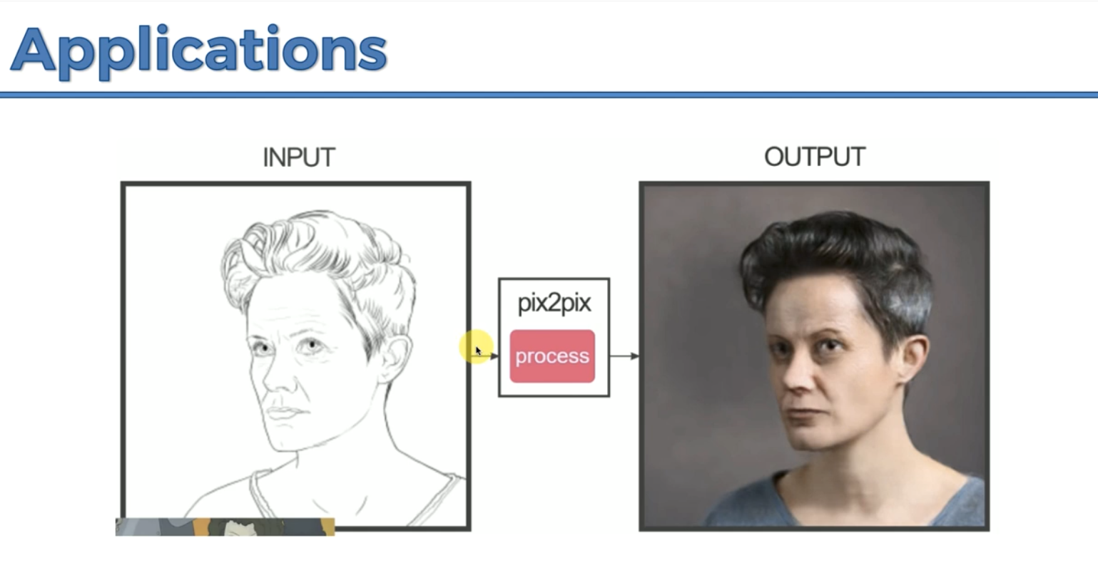

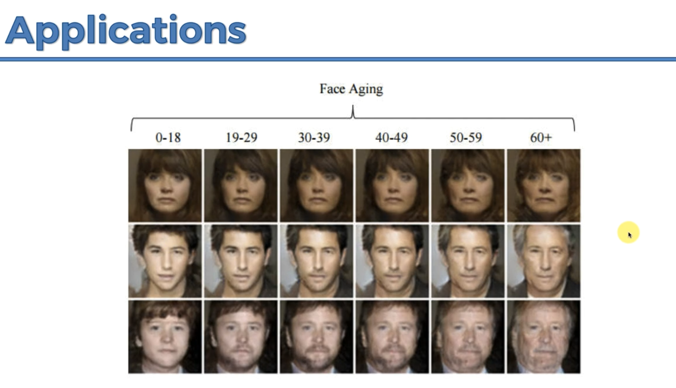

**CODE**

nn.ConvTranspose2d(100, 512, 4, 1, 0, bias = False)- The generator is an inverse convolution and that’s why you use the nn.ConvTranspose2d where 100 is the number of inputs meaning our CNN will be a vector of size 100, 512 is the number of feature maps of the output, 4 is the size of the kernel which is 4 * 4, 1 is the stride, 0 is the padding.

You’re supposed to apply a batchNormalization for the number of feature maps.

In the second convolution, the number of feature maps becomes the number of inputs.

nn.ReLU(True) – breaks the linearity.

nn.Tanh() – is the hyperbolic tangent to break the linearity and make the values between -1 and 1.

